Centrality Lab

For this lab we will use 3 datasets:
WIRING:
This is a stacked dataset that includes many different files. We will be working with RDGAM. This is a dichotomous adjacency matrix of 14 employees of the bank wiring room of Western Electric. Ties are symmetric and represent participation in games during work breaks.
PRISON:
This is a dichotomous adjacency matrix of 67 prisoners. Ties are directed and represent each ego’s friends. Each was free to choose as few or as many "friends" as he desired.
DRUGNET:
This is a dichotomous adjacency matrix of drug users in Hartford. Ties are directed and represent the lending of drug needles. We will also work with the attribute file DRUGATTR.
EXERCISES:
- Centrality using UCINET and NetDraw with RDGAM
If you have not done so already use UCINET to unpack WIRING (Data | Unpack). Be sure to eliminate the prefix so you filenames match what I have here.

a) Open RDGAM in Netdraw to familiarize yourself with the data
In UCINET calculate the following measures of centrality using
Network | Centrality & Power |
Degree
Freeman Betweenness | Node Betweenness
Closeness measures
Eigenvector

- Using your Netdraw visualization, compare your calculations of various Centrality measures

In below diagrams, the size of square indicates the degree to which a specific node is central in the network. Thus, the bigger square nodes are more central than smaller square nodes.

Degree centrality
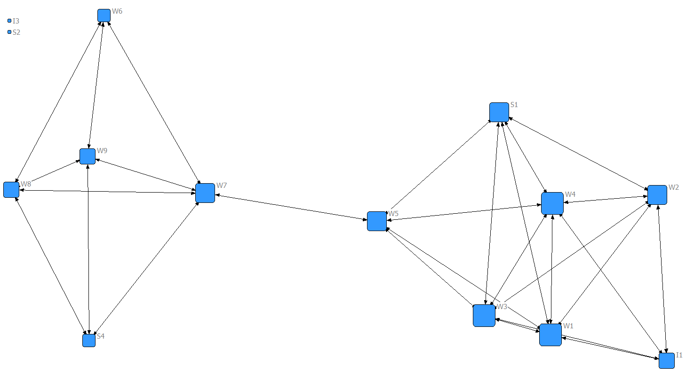
Betweenness centrality
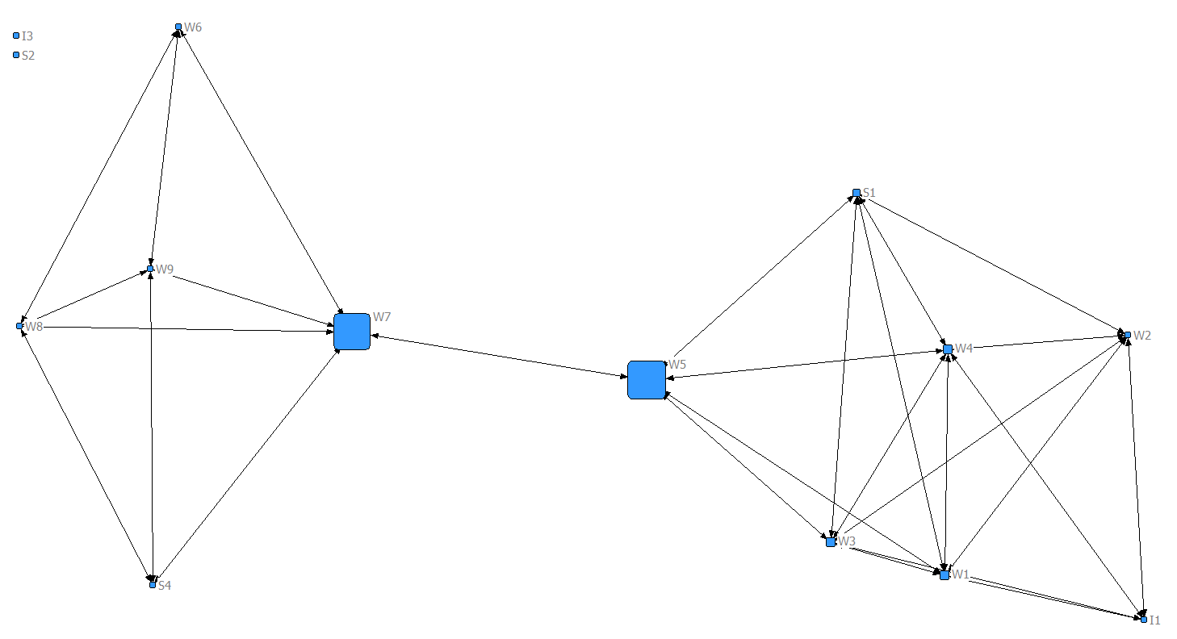

Closeness centrality
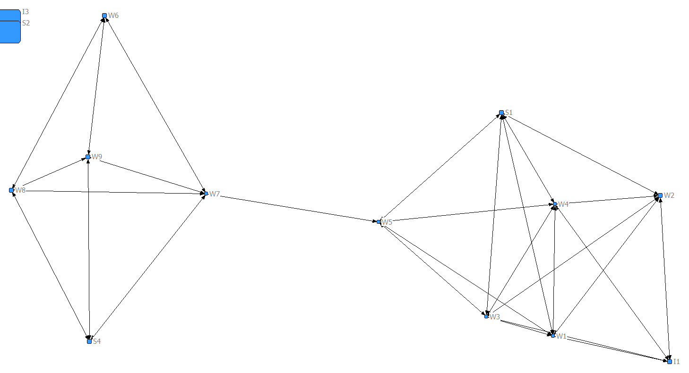
Eigenvector centrality
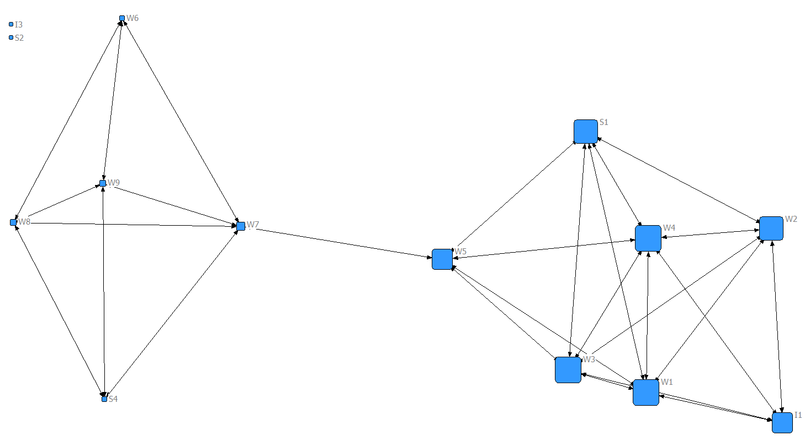

- Now run Centrality multiple measures in UCINET using Network | Centrality | Multiple Measures. Be sure to indicate you want “Raw” scores.

MULTIPLE CENTRALITY MEASURES
--------------------------------------------------------------------------------
Input dataset: WIRING-RDGAM (C:\Users\kihojun\Documents\UCINET data\WIRING-RDGAM)
Output dataset: WIRING-RDGAM-cent (C:\Users\kihojun\Documents\UCINET data\WIRING-RDGAM-cent)
Treat data as: Auto-detect
Type of scores to output: Raw scores
Undefined dist in closeness: replace with max dist + 1
Network RDGAM is directed? NO
Value of Beta was: 0.188805369194129
Centrality Measures

1 2 3 4 5 6 7 8 9
Degree 2local BonPwr 2Step ARD Closenes Eigenvec Between 2StepBet
-------- -------- -------- -------- -------- -------- -------- -------- --------
1 I1 4.000 23.000 911.060 6.000 6.333 37.000 0.307 0.000 0.000
2 I3 0.000 0.000 0.000 0.000 0.000 65.000 0.000 0.000 0.000
3 W1 6.000 31.000 1239.520 7.000 7.833 30.000 0.417 3.750 0.833
4 W2 5.000 27.000 1085.647 6.000 6.833 36.000 0.365 0.250 0.250
5 W3 6.000 31.000 1239.520 7.000 7.833 30.000 0.417 3.750 0.833
6 W4 6.000 31.000 1239.520 7.000 7.833 30.000 0.417 3.750 0.833
7 W5 5.000 28.000 963.556 11.000 8.000 27.000 0.323 30.000 4.000
8 W6 3.000 13.000 94.662 5.000 5.833 37.000 0.029 0.000 0.000
9 W7 5.000 19.000 264.410 9.000 7.667 29.000 0.085 28.333 4.333
10 W8 4.000 15.000 110.538 5.000 6.333 36.000 0.033 0.333 0.333
11 W9 4.000 15.000 110.538 5.000 6.333 36.000 0.033 0.333 0.333
12 S1 5.000 28.000 1093.985 7.000 7.333 31.000 0.368 1.500 0.250
13 S2 0.000 0.000 0.000 0.000 0.000 65.000 0.000 0.000 0.000
14 S4 3.000 13.000 94.662 5.000 5.833 37.000 0.029 0.000 0.000

Based on diagrams and UCINET output, we can tell as follows:
First of all, with respect to degree centrality, W1, W3, and W4 have the greatest degree, which means that they might be regarded as the most influential. Second, regarding betweenness centrality, W5 and W7 are in a favored position to the extent that the actor falls on the geodesic paths between other pairs of actors in the network. In other words, the more people depend on a specific node to make connections with other nodes, the more power that node has. We can check this by looking at diagram. Third, according to definition of Freeman, large numbers of closeness indicate that a node is highly peripheral (I3, S2), while small numbers indicate that a node is more central. We can check this through looking at diagram. Finally, eigenvector centrality scores show that W1, W3, and W4 are connected to other nodes that are themselves well connected.

- Compare the profile of W1 with W5 across all measures. Note that W1 is stronger in eigenvector while W5 is stronger on betweenness. Interpret this result

Degree 2local BonPwr 2Step ARD Closenes Eigenvec Between 2StepBet
-------- -------- -------- -------- -------- -------- -------- -------- --------
1 I1 4.000 23.000 911.060 6.000 6.333 37.000 0.307 0.000 0.000
2 I3 0.000 0.000 0.000 0.000 0.000 65.000 0.000 0.000 0.000
3 W1 6.000 31.000 1239.520 7.000 7.833 30.000 0.417 3.750 0.833
4 W2 5.000 27.000 1085.647 6.000 6.833 36.000 0.365 0.250 0.250
5 W3 6.000 31.000 1239.520 7.000 7.833 30.000 0.417 3.750 0.833
6 W4 6.000 31.000 1239.520 7.000 7.833 30.000 0.417 3.750 0.833
7 W5 5.000 28.000 963.556 11.000 8.000 27.000 0.323 30.000 4.000
8 W6 3.000 13.000 94.662 5.000 5.833 37.000 0.029 0.000 0.000
9 W7 5.000 19.000 264.410 9.000 7.667 29.000 0.085 28.333 4.333
10 W8 4.000 15.000 110.538 5.000 6.333 36.000 0.033 0.333 0.333
11 W9 4.000 15.000 110.538 5.000 6.333 36.000 0.033 0.333 0.333
12 S1 5.000 28.000 1093.985 7.000 7.333 31.000 0.368 1.500 0.250
13 S2 0.000 0.000 0.000 0.000 0.000 65.000 0.000 0.000 0.000
14 S4 3.000 13.000 94.662 5.000 5.833 37.000 0.029 0.000 0.000

Betweennes centrality is a measure of how often a given node falls along the shortest path between two other nodes. In other words, it is, loosely, the extent to which a given node is along the shortest paths of between all pairs of nodes. It is often interpreted as control over flows. Therefore, we can interpret W5 is the most influential node in terms of control over flows of information or something valuable. With respect to eigenvector, a node has high eigenvector score to the extent it is connected to many nodes who themselves have high scores. It is often interpreted as popularity or status – have ties not just to many others but many well-connected others. Therefore, we might interpret that W1 is the most famous or popular node in this network.

- Compare W5 with W7. They have same degree yet differ on eigenvector centrality. Why is W7 so much weaker on eigenvector centrality?

Degree 2local BonPwr 2Step ARD Closenes Eigenvec Between 2StepBet
-------- -------- -------- -------- -------- -------- -------- -------- --------
1 I1 4.000 23.000 911.060 6.000 6.333 37.000 0.307 0.000 0.000
2 I3 0.000 0.000 0.000 0.000 0.000 65.000 0.000 0.000 0.000
3 W1 6.000 31.000 1239.520 7.000 7.833 30.000 0.417 3.750 0.833
4 W2 5.000 27.000 1085.647 6.000 6.833 36.000 0.365 0.250 0.250
5 W3 6.000 31.000 1239.520 7.000 7.833 30.000 0.417 3.750 0.833
6 W4 6.000 31.000 1239.520 7.000 7.833 30.000 0.417 3.750 0.833
7 W5 5.000 28.000 963.556 11.000 8.000 27.000 0.323 30.000 4.000
8 W6 3.000 13.000 94.662 5.000 5.833 37.000 0.029 0.000 0.000
9 W7 5.000 19.000 264.410 9.000 7.667 29.000 0.085 28.333 4.333
10 W8 4.000 15.000 110.538 5.000 6.333 36.000 0.033 0.333 0.333
11 W9 4.000 15.000 110.538 5.000 6.333 36.000 0.033 0.333 0.333
12 S1 5.000 28.000 1093.985 7.000 7.333 31.000 0.368 1.500 0.250
13 S2 0.000 0.000 0.000 0.000 0.000 65.000 0.000 0.000 0.000
14 S4 3.000 13.000 94.662 5.000 5.833 37.000 0.029 0.000 0.000

A node with high eigenvector centrality is connected to nodes that are well connected to other nodes in network. Comparing W5 with W7, W5 is connected to nodes that have more connections to others than W7. According to netdraw diagram, we can also find the nodes that W5 is connected to are relatively well connected to others in the network.

- Remove isolates using Data | Remove | Remove Isolates on RDGAM and recalculate centrality measures on the resultant data set, making sure to use whatever you specify as an Output dataset when removing isolates as the input dataset for calculating centrality. (That is, when you remove isolates, it creates a NEW dataset, and RDGAM will still have the isolates. Run it on the new file.)

Centrality output before removing isolates

Degree 2local BonPwr 2Step ARD Closenes Eigenvec Between 2StepBet
-------- -------- -------- -------- -------- -------- -------- -------- --------
1 I1 4.000 23.000 911.060 6.000 6.333 37.000 0.307 0.000 0.000
2 I3 0.000 0.000 0.000 0.000 0.000 65.000 0.000 0.000 0.000
3 W1 6.000 31.000 1239.520 7.000 7.833 30.000 0.417 3.750 0.833
4 W2 5.000 27.000 1085.647 6.000 6.833 36.000 0.365 0.250 0.250
5 W3 6.000 31.000 1239.520 7.000 7.833 30.000 0.417 3.750 0.833
6 W4 6.000 31.000 1239.520 7.000 7.833 30.000 0.417 3.750 0.833
7 W5 5.000 28.000 963.556 11.000 8.000 27.000 0.323 30.000 4.000
8 W6 3.000 13.000 94.662 5.000 5.833 37.000 0.029 0.000 0.000
9 W7 5.000 19.000 264.410 9.000 7.667 29.000 0.085 28.333 4.333
10 W8 4.000 15.000 110.538 5.000 6.333 36.000 0.033 0.333 0.333
11 W9 4.000 15.000 110.538 5.000 6.333 36.000 0.033 0.333 0.333
12 S1 5.000 28.000 1093.985 7.000 7.333 31.000 0.368 1.500 0.250
13 S2 0.000 0.000 0.000 0.000 0.000 65.000 0.000 0.000 0.000
14 S4 3.000 13.000 94.662 5.000 5.833 37.000 0.029 0.000 0.000

Centrality output after removing isolates

Degree BonPwr 2Step ARD Closenes Eigenvec Between 2StepBet
-------- -------- -------- -------- -------- -------- -------- --------
1 I1 4.000 911.060 6.000 6.333 27.000 0.307 0.000 0.000
2 W1 6.000 1239.520 7.000 7.833 20.000 0.417 3.750 0.833
3 W2 5.000 1085.647 6.000 6.833 26.000 0.365 0.250 0.250
4 W3 6.000 1239.520 7.000 7.833 20.000 0.417 3.750 0.833
5 W4 6.000 1239.520 7.000 7.833 20.000 0.417 3.750 0.833
6 W5 5.000 963.556 11.000 8.000 17.000 0.323 30.000 4.000
7 W6 3.000 94.662 5.000 5.833 27.000 0.029 0.000 0.000
8 W7 5.000 264.410 9.000 7.667 19.000 0.085 28.333 4.333
9 W8 4.000 110.538 5.000 6.333 26.000 0.033 0.333 0.333
10 W9 4.000 110.538 5.000 6.333 26.000 0.033 0.333 0.333
11 S1 5.000 1093.985 7.000 7.333 21.000 0.368 1.500 0.250
12 S4 3.000 94.662 5.000 5.833 27.000 0.029 0.000 0.000
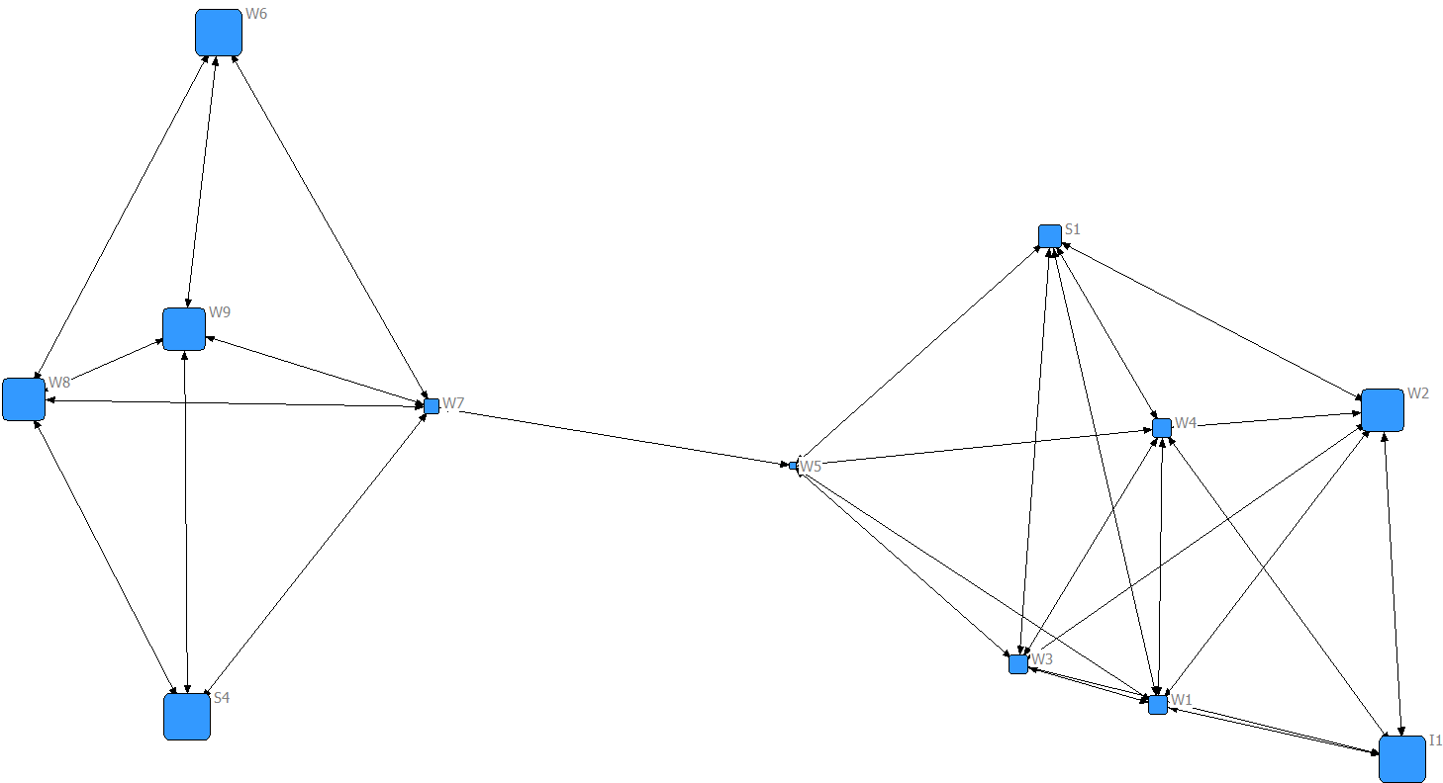
- Compare the results for closeness centrality with those from the previous run. (Use File | View Previous Output to see prior output). What happened and why?

The mean farness went from 51 on the unconnected network with isolates to 23 on the connected network with isolates removed. You can also see the changes in individual measures for the network when you tell UCINET to substitute N for the missing distances. The values in the previous two tables, however, used Diameter Plus+1, which is 5, so the numbers when down by 10 (because the diameter is 4, so it used 5 for the values for the two isolates).

- Directed Centrality using UCINET with PRISON

a) Open PRISON in Netdraw to familiarize yourself with the data
b) Using UCINET calculate Centrality measures, remembering that these are directed data.

MULTIPLE CENTRALITY MEASURES
--------------------------------------------------------------------------------

Input dataset: PRISON (C:\Users\kihojun\Documents\UCINET data\PRISON)
Output dataset: PRISON-cent (C:\Users\kihojun\Documents\UCINET data\PRISON-cent)
Treat data as: Directed
Type of scores to output: Raw scores
Undefined dist in closeness: replace with max dist + 1

Value of Beta was: 0.298764280458922
Principal eigenvalue was: 0
Centrality Measures

1 2 3 4 5 6 7 8 9
OutDeg Indeg OutBonPw InBonPwr OutClose InClose OutEigen InEigen Between
-------- -------- -------- -------- -------- -------- -------- -------- --------
1 2.000 0.000 4.805 0.000 724.000 792.000 1.000 0.198 0.000
2 3.000 1.000 454.749 6.180 426.000 501.000 0.000 0.126 83.198
3 3.000 1.000 509.908 110.925 477.000 380.000 0.000 0.000 115.500
4 1.000 4.000 2.930 589.367 735.000 325.000 0.000 -0.324 0.000
5 3.000 4.000 6.459 589.367 730.000 325.000 0.000 -0.324 50.700
6 1.000 2.000 3.002 395.344 737.000 366.000 0.000 0.188 2.000
7 1.000 4.000 1.945 246.499 771.000 273.000 0.000 0.232 38.167
8 8.000 5.000 362.353 54.783 390.000 395.000 0.000 0.126 627.050
9 3.000 3.000 6.702 1315.144 732.000 312.000 0.000 0.000 130.233
10 2.000 1.000 249.752 1.426 445.000 781.000 0.000 0.000 48.000
11 1.000 1.000 75.617 1.426 493.000 781.000 0.000 0.000 0.000
12 4.000 4.000 515.432 49.911 382.000 402.000 0.000 0.000 276.583
13 2.000 2.000 291.855 17.338 401.000 453.000 0.000 0.000 116.532
14 2.000 1.000 62.084 1.426 447.000 771.000 0.000 0.117 47.897
15 3.000 3.000 117.504 13.177 500.000 464.000 0.000 0.014 0.500
16 2.000 7.000 176.051 43.342 458.000 365.000 0.000 -0.126 368.667
17 2.000 3.000 89.704 13.177 501.000 464.000 0.000 0.014 0.000
18 4.000 3.000 794.907 19.619 415.000 447.000 0.000 0.000 106.867
19 0.000 1.000 0.000 1.000 792.000 781.000 0.000 0.019 0.000
20 3.000 3.000 753.639 9.288 420.000 495.000 0.000 0.271 97.783
21 2.000 6.000 320.059 367.933 458.000 327.000 0.000 0.000 256.000
22 3.000 2.000 767.192 2051.740 524.000 379.000 0.000 -0.006 0.000
23 3.000 2.000 648.496 30.074 436.000 420.000 0.000 0.023 3.333
24 3.000 3.000 648.496 93.966 436.000 368.000 0.000 0.139 55.333
25 0.000 2.000 0.000 3.846 792.000 538.000 0.000 -0.680 0.000
26 0.000 2.000 0.000 2.426 792.000 751.000 0.000 0.141 0.000
27 3.000 0.000 456.051 0.000 426.000 792.000 0.000 -0.117 0.000
28 3.000 4.000 236.662 32.430 491.000 413.000 0.000 0.207 141.100
29 1.000 2.000 109.258 18.793 436.000 442.000 0.000 0.045 64.500
30 5.000 5.000 592.551 481.974 403.000 296.000 0.000 0.009 883.229
31 4.000 0.000 153.610 0.000 489.000 792.000 0.000 0.112 0.000
32 3.000 1.000 325.334 80.124 398.000 383.000 0.000 -0.126 576.383
33 2.000 4.000 201.108 264.836 422.000 330.000 0.000 0.000 617.864
34 2.000 3.000 116.002 29.747 437.000 442.000 0.000 0.207 164.083
35 0.000 1.000 0.000 11.200 792.000 475.000 0.000 1.000 0.000
36 3.000 0.000 767.138 0.000 421.000 792.000 0.000 0.000 0.000
37 6.000 6.000 957.383 274.399 406.000 318.000 0.000 0.117 615.692
38 1.000 1.000 53.747 1.426 468.000 781.000 0.000 0.000 0.000
39 4.000 1.000 329.102 8.415 492.000 500.000 0.000 -0.005 0.000
40 2.000 2.000 3.162 135.095 770.000 280.000 0.000 -0.009 32.033
41 5.000 5.000 1009.115 46.340 393.000 398.000 0.000 -0.271 371.216
42 2.000 2.000 144.915 16.375 424.000 493.000 0.000 0.081 56.000
43 2.000 2.000 582.506 83.981 428.000 365.000 0.000 -0.276 291.430
44 3.000 1.000 176.551 1.426 418.000 781.000 0.000 0.000 50.000
45 4.000 3.000 708.456 25.481 397.000 447.000 0.000 0.005 175.683
46 3.000 4.000 117.504 20.886 500.000 414.000 0.000 -0.126 125.500
47 2.000 6.000 235.445 32.181 494.000 423.000 0.000 -0.203 126.517
48 2.000 6.000 465.065 260.690 434.000 309.000 0.000 -0.302 355.821
49 4.000 4.000 807.855 3407.193 481.000 337.000 0.000 0.136 183.567
50 3.000 1.000 233.174 1.426 404.000 771.000 0.000 -0.126 90.500
51 1.000 4.000 71.343 21.967 539.000 411.000 0.000 -0.063 81.517
52 3.000 8.000 554.674 993.122 420.000 293.000 0.000 0.392 762.046
53 3.000 0.000 108.449 0.000 453.000 792.000 0.000 0.000 0.000
54 5.000 3.000 544.706 24.817 452.000 447.000 0.000 0.000 267.167
55 4.000 7.000 933.909 2478.430 449.000 298.000 0.000 0.006 609.834
56 4.000 7.000 982.796 3453.533 486.000 327.000 0.000 -0.136 132.908
57 1.000 4.000 1.945 198.984 771.000 259.000 0.000 -0.232 51.867
58 3.000 2.000 257.986 18.367 396.000 444.000 0.000 -0.207 94.667
59 2.000 1.000 79.534 1.426 425.000 781.000 0.000 0.000 46.000
60 2.000 1.000 26.343 1.426 468.000 781.000 0.000 0.000 2.500
61 4.000 1.000 393.828 34.141 474.000 432.000 0.000 0.000 59.000
62 5.000 1.000 432.140 1.426 363.000 781.000 0.000 0.000 15.000
63 5.000 0.000 681.152 0.000 392.000 792.000 0.000 -0.139 0.000
64 3.000 4.000 767.192 3407.193 524.000 337.000 0.000 0.136 19.792
65 2.000 0.000 79.077 0.000 426.000 792.000 0.000 -0.126 0.000
66 3.000 1.000 307.415 1.426 390.000 781.000 0.000 0.000 3.333
67 2.000 4.000 341.102 309.527 434.000 322.000 0.000 0.000 149.907

c) Identify which individuals have the most friends in this dataset. (What measure(s) did you use to identity them, and why?)

For directed data, the adjacency matrix is not always symmetric. Therefore, the row and column sums may be different. Generally, outdegree counts the number of outgoing ties whereas indegree counts the number of incoming ties. In this case, interpretation of this asymmetric data depends on what kind of social relation we explore. For example, you might interpret outdegree of friendship ties as the ‘gregariousness’ of the node, whereas the indegree as the ‘popularity’ of the node. Therefore, if you use ‘indegree’ of ties to identify which individuals have the most friends, you interpret ‘friendship’ as ‘popularity of individuals.’

3) Directed Centrality using NetDraw with PRISON

a) Open PRISON in Netdraw

b) Using NetDraw calculate Centrality measures under Analysis | Centrality measures. Tell the
routine you have directed data.
c) Resize the nodes based on various Centrality measures. (don’t worry about measures we didn’t
talk about).
After you run the centrality measures you should be able to click the “Size” box on the “Nodes” tab then click through the different types of centrality.
InDegree centrality
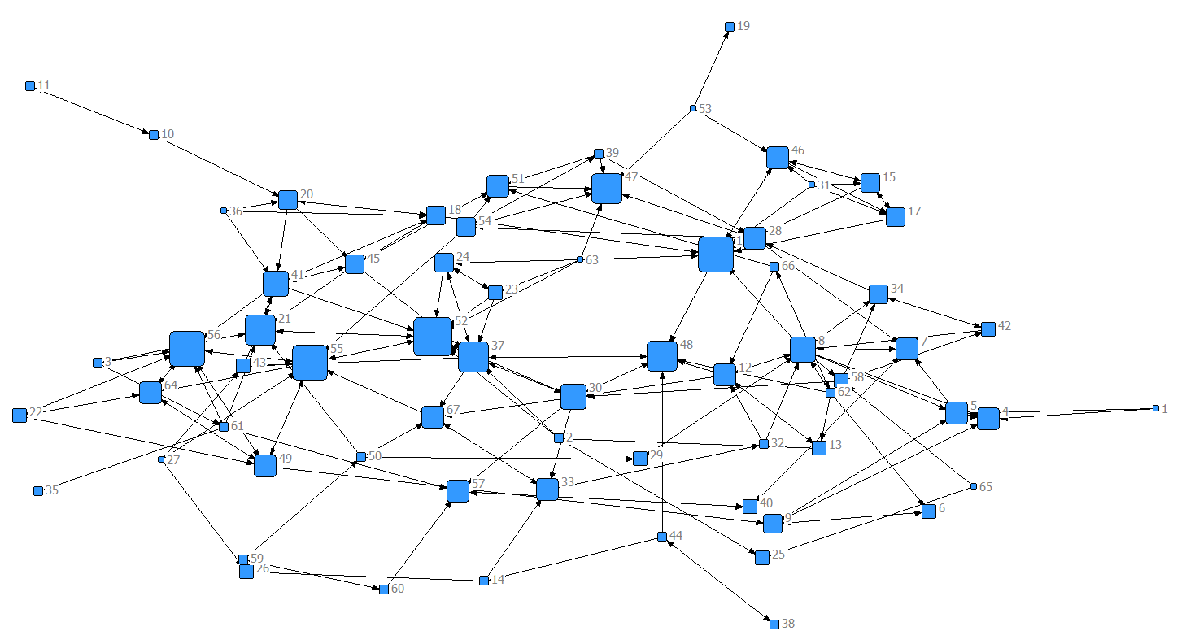

OutDegree centrality
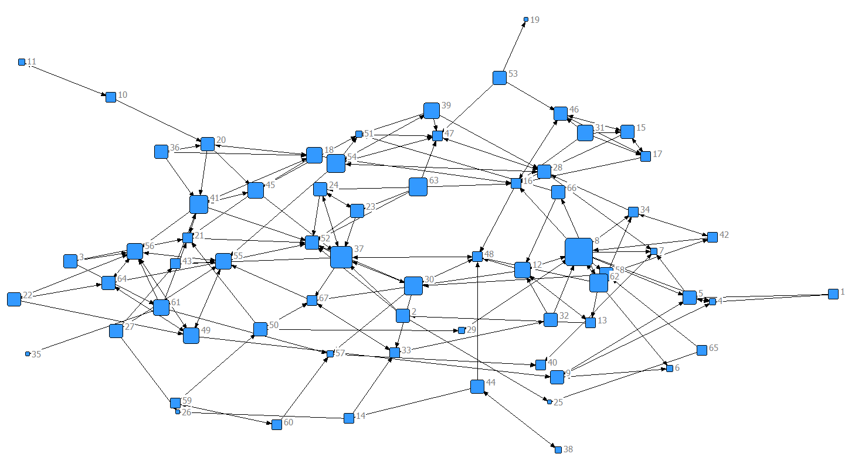
Betweenness centrality
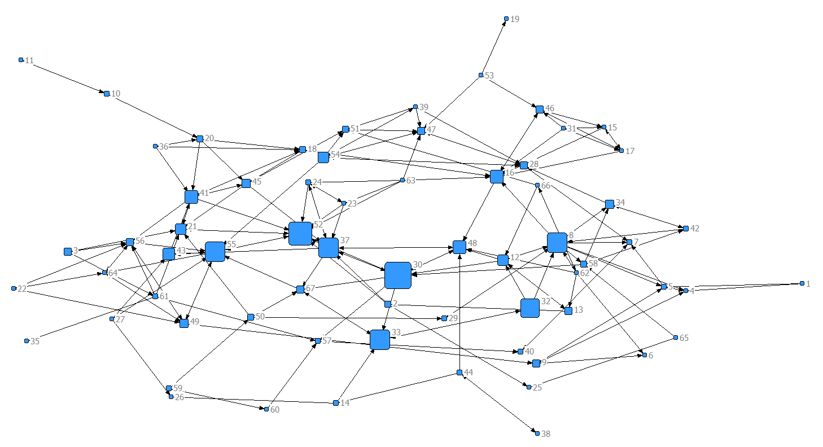

InCloseness centrality
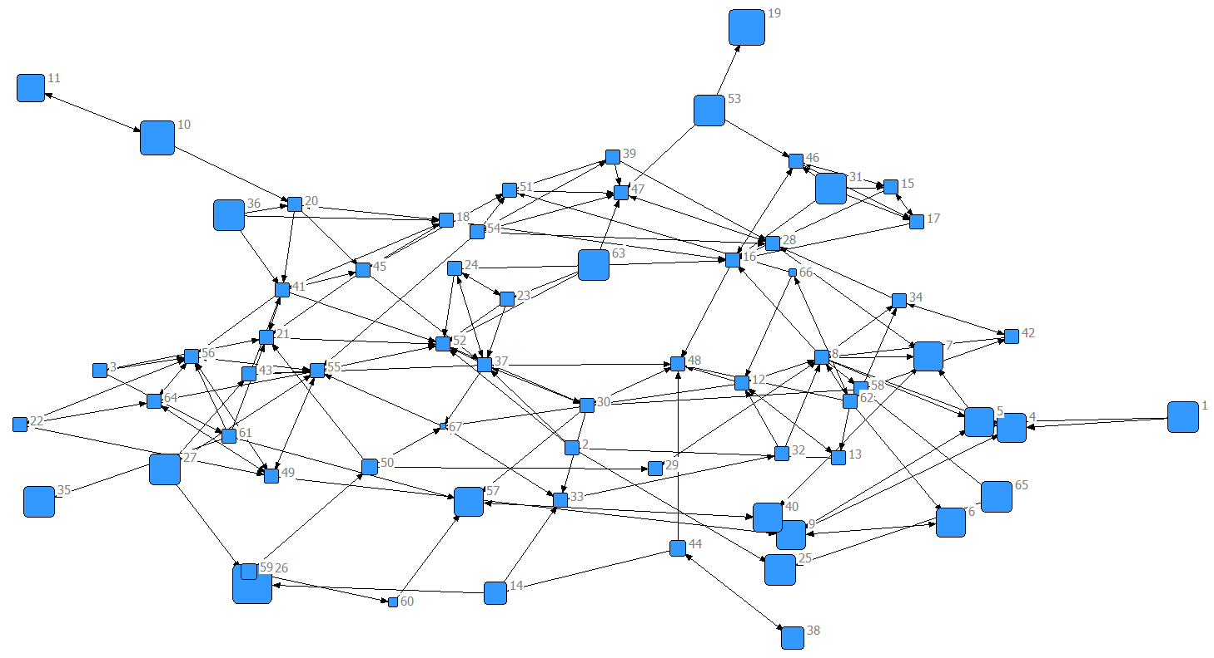

OutCloseness centrality
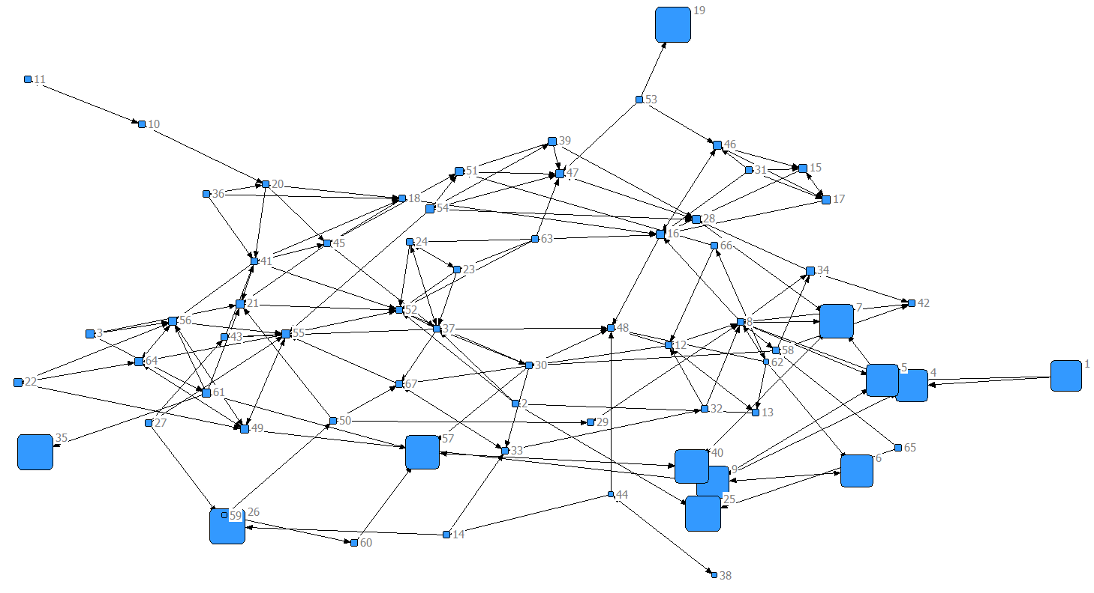
InEigenvector centrality
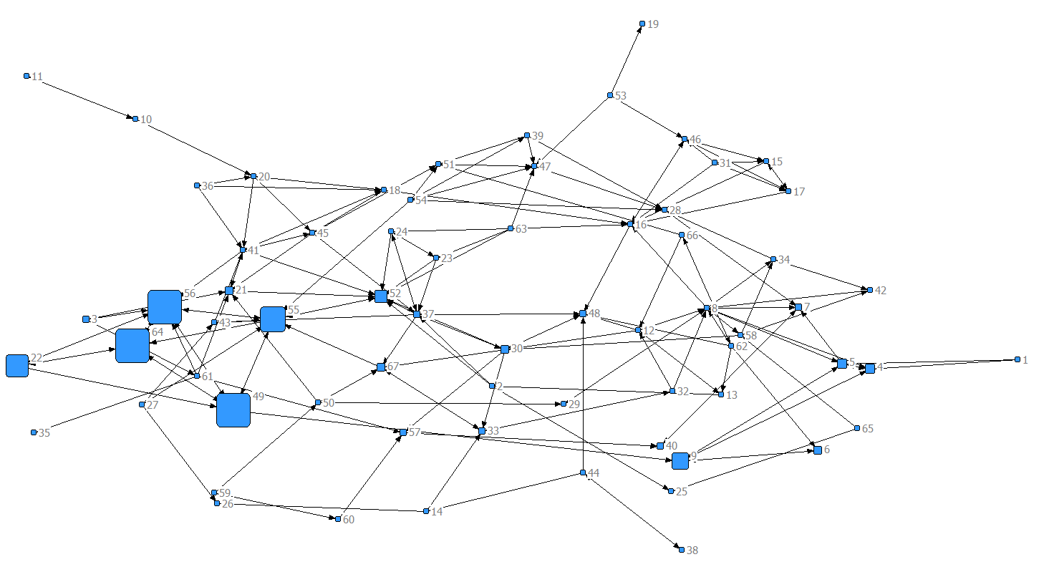

OutEigenvector centrality
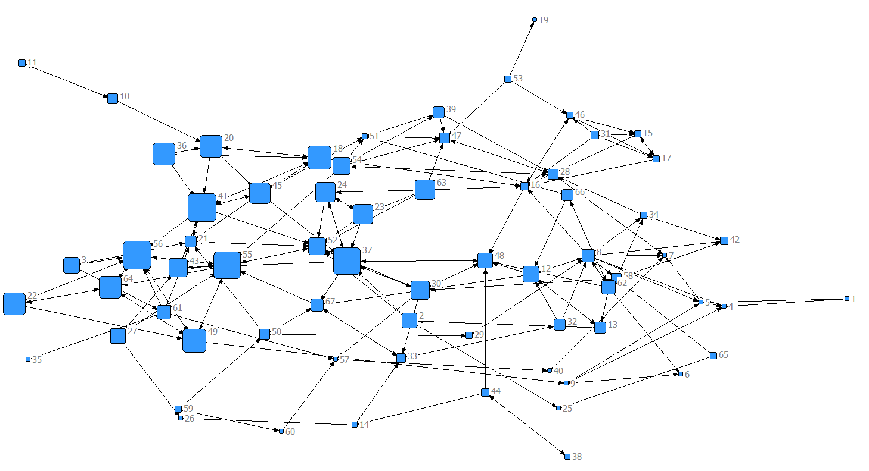
d) Identify which individuals list the most number of friends
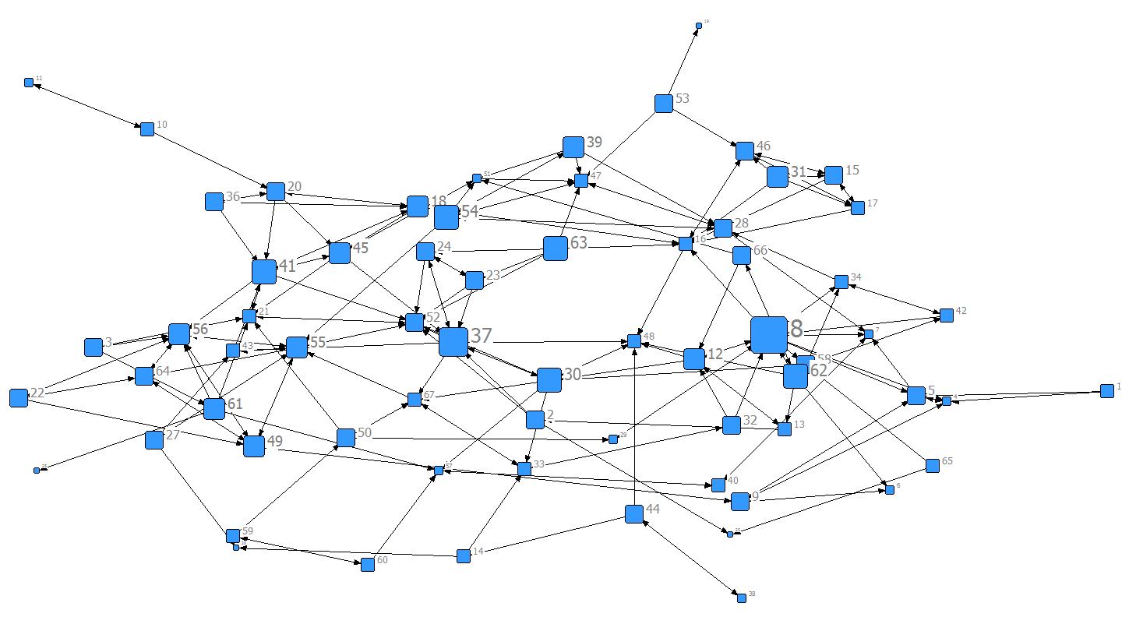
Outdegree centrality would be the correct centrality measure to choose. It is based on who nominated the most other people. You can tell by sizing your network by outdegree that node 8 has the highest outdegree. To get a more refined idea of who the nodes are with most outdegree you can also uncheck the boxes in the nodes tab to only show individuals with the 5 or greater outdegree.

e) Identify which individuals are listed as friends by the most number of others
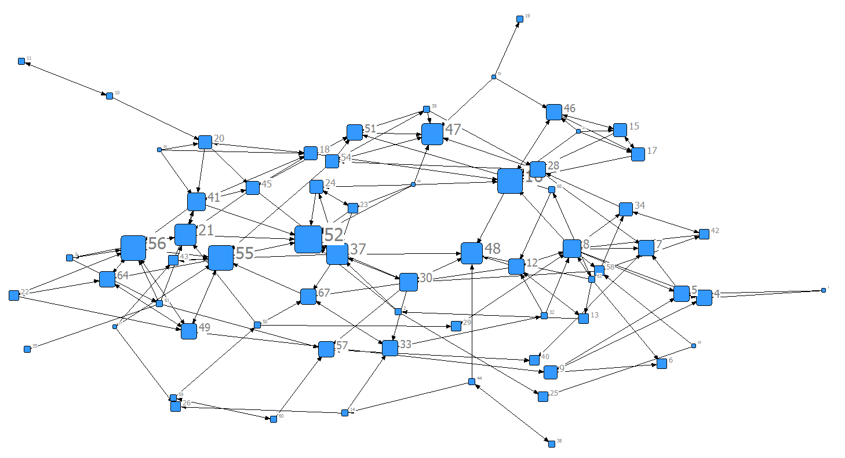
Indegree would be the type of centrality that identified who received the most nominations by others.
Repeat what you did for step D with indegree. You should find node 53 has the highest indegree (8) followed by 16,55, and 56 (all with 7).
FREEMAN DEGREE CENTRALITY
1 2 3 4
Outde Indeg nOutd nInde
g eg g
----- ----- ----- -----
1 2.000 0.000 0.030 0.000
2 3.000 1.000 0.045 0.015
3 3.000 1.000 0.045 0.015
4 1.000 4.000 0.015 0.061
5 3.000 4.000 0.045 0.061
6 1.000 2.000 0.015 0.030
7 1.000 4.000 0.015 0.061
8 8.000 5.000 0.121 0.076
9 3.000 3.000 0.045 0.045
10 2.000 1.000 0.030 0.015
11 1.000 1.000 0.015 0.015
12 4.000 4.000 0.061 0.061
13 2.000 2.000 0.030 0.030
14 2.000 1.000 0.030 0.015
15 3.000 3.000 0.045 0.045
16 2.000 7.000 0.030 0.106
17 2.000 3.000 0.030 0.045
18 4.000 3.000 0.061 0.045
19 0.000 1.000 0.000 0.015
20 3.000 3.000 0.045 0.045
21 2.000 6.000 0.030 0.091
22 3.000 2.000 0.045 0.030
23 3.000 2.000 0.045 0.030
24 3.000 3.000 0.045 0.045
25 0.000 2.000 0.000 0.030
26 0.000 2.000 0.000 0.030
27 3.000 0.000 0.045 0.000
28 3.000 4.000 0.045 0.061
29 1.000 2.000 0.015 0.030
30 5.000 5.000 0.076 0.076
31 4.000 0.000 0.061 0.000
32 3.000 1.000 0.045 0.015
33 2.000 4.000 0.030 0.061
34 2.000 3.000 0.030 0.045
35 0.000 1.000 0.000 0.015
36 3.000 0.000 0.045 0.000
37 6.000 6.000 0.091 0.091
38 1.000 1.000 0.015 0.015
39 4.000 1.000 0.061 0.015
40 2.000 2.000 0.030 0.030
41 5.000 5.000 0.076 0.076
42 2.000 2.000 0.030 0.030
43 2.000 2.000 0.030 0.030
44 3.000 1.000 0.045 0.015
45 4.000 3.000 0.061 0.045
46 3.000 4.000 0.045 0.061
47 2.000 6.000 0.030 0.091
48 2.000 6.000 0.030 0.091
49 4.000 4.000 0.061 0.061
50 3.000 1.000 0.045 0.015
51 1.000 4.000 0.015 0.061
52 3.000 8.000 0.045 0.121
53 3.000 0.000 0.045 0.000
54 5.000 3.000 0.076 0.045
55 4.000 7.000 0.061 0.106
56 4.000 7.000 0.061 0.106
57 1.000 4.000 0.015 0.061
58 3.000 2.000 0.045 0.030
59 2.000 1.000 0.030 0.015
60 2.000 1.000 0.030 0.015
61 4.000 1.000 0.061 0.015
62 5.000 1.000 0.076 0.015
63 5.000 0.000 0.076 0.000
64 3.000 4.000 0.045 0.061
65 2.000 0.000 0.030 0.000
66 3.000 1.000 0.045 0.015
67 2.000 4.000 0.030 0.061

4) Directed Centrality using UCINET with DRUGNET

- Open DRUGNET in NetDraw to familiarize yourself with the data

- Using UCINET identify which individuals are at highest risk of contracting a disease based on their needle sharing habits.

Drugnet is a needle sharing network taking from a US city. Needles are either given (out-arrows), received (in arrows), or traded (bi-directional arrows).
First, consider what measures of Centrality to use based on the data and problem. We can use eigenvector centrality to identify individuals at higher risk of contracting a disease. In the case of directed network, we could interpret left eigenvector (columns) is popularity, whereas right eigenvector (rows) is influence. Therefore, we can interpret eigenvector centrality as a measure of popularity. In addition, we could also view eigenvector centrality as a measure of risk. Therefore, by looking at eigenvector centrality score, we could identify individuals who are at highest risk of contracting a disease. However, we should remember it is better to use beta centrality as a substitute for eigenvector centrality. Therefore, we could identify that node 150, 171, 173 are at highest risk of contracting a disease by looking at beta centrality score and eigenvector centrality. We could also identify those individuals through two diagrams.
On the other hand, indegree centrality shows the individuals who are receiving the most needles from other and at the most immediate risk of contracting a pathogen that travels by needles. Betweeness centrality also shows the individuals who are most necessary for flows through the network, such as disease, to pass through to get to others. These individuals may not be at high risk themselves but if you wanted to prevent a disease from traveling through the network they would be important to intervene with.

FREEMAN'S DEGREE CENTRALITY MEASURES
--------------------------------------------------------------------------------

Diagonal valid? NO
Model: ASYMMETRIC
Input dataset: drugnet (C:\Users\Adam\Documents\UCINET data\drugnet)

1 2 3 4
OutDegree InDegree NrmOutDeg NrmInDeg
------------ ------------ ------------ ------------
55 55 5.00 3.00 1.71 1.03
31 31 5.00 4.00 1.71 1.37
50 50 5.00 10.00 1.71 3.42
58 58 5.00 2.00 1.71 0.68
82 83 5.00 1.00 1.71 0.34
49 49 5.00 1.00 1.71 0.34
148 150 4.00 4.00 1.37 1.37
190 192 4.00 0.00 1.37 0.00
66 66 4.00 0.00 1.37 0.00
170 172 4.00 1.00 1.37 0.34
146 148 4.00 1.00 1.37 0.34
64 64 4.00 8.00 1.37 2.74
214 216 4.00 1.00 1.37 0.34
191 193 4.00 0.00 1.37 0.00
7 7 3.00 3.00 1.03 1.03
38 38 3.00 10.00 1.03 3.42
94 95 3.00 1.00 1.03 0.34
149 151 3.00 2.00 1.03 0.68
169 171 3.00 3.00 1.03 1.03
198 200 3.00 2.00 1.03 0.68
171 173 3.00 5.00 1.03 1.71
83 84 3.00 1.00 1.03 0.34
23 23 3.00 1.00 1.03 0.34
104 105 3.00 2.00 1.03 0.68
74 74 3.00 1.00 1.03 0.34
111 113 3.00 2.00 1.03 0.68
18 18 3.00 2.00 1.03 0.68
67 67 3.00 1.00 1.03 0.34
24 24 3.00 2.00 1.03 0.68
107 108 3.00 2.00 1.03 0.68
22 22 3.00 5.00 1.03 1.71
207 209 3.00 2.00 1.03 0.68
43 43 3.00 3.00 1.03 1.03
9 9 3.00 1.00 1.03 0.34
92 93 3.00 0.00 1.03 0.00
37 37 3.00 3.00 1.03 1.03
17 17 2.00 0.00 0.68 0.00
208 210 2.00 0.00 0.68 0.00
138 140 2.00 1.00 0.68 0.34
11 11 2.00 0.00 0.68 0.00
141 143 2.00 1.00 0.68 0.34
20 20 2.00 4.00 0.68 1.37
35 35 2.00 4.00 0.68 1.37
234 236 2.00 0.00 0.68 0.00
78 79 2.00 1.00 0.68 0.34
42 42 2.00 1.00 0.68 0.34
84 85 2.00 1.00 0.68 0.34
36 36 2.00 0.00 0.68 0.00
280 285 2.00 0.00 0.68 0.00
187 189 2.00 1.00 0.68 0.34
10 10 2.00 4.00 0.68 1.37
8 8 2.00 2.00 0.68 0.68
4 4 2.00 3.00 0.68 1.03
54 54 2.00 1.00 0.68 0.34
197 199 2.00 0.00 0.68 0.00

[Remaining rows deleted]

BETA CENTRALITY / BONACICH POWER
--------------------------------------------------------------------------------
Beta value is 0.426837418476662

Bonacich Power

1 2
Beta Ce Normali
------- -------
1 1 44.598 0.320
2 2 45.299 0.325
3 3 8.637 0.062
4 4 8.637 0.062
5 5 0.000 0.000
6 6 1.000 0.007
7 7 13.206 0.095
8 8 19.451 0.139
9 9 6.637 0.048
10 10 45.521 0.326
11 11 0.000 0.000
12 12 0.000 0.000
13 13 1.745 0.013
14 14 69.854 0.501
15 15 548.401 3.929
16 16 7.379 0.053
17 17 0.000 0.000
18 18 14.293 0.102
19 19 28.800 0.206
20 20 7.935 0.057
21 21 14.944 0.107
22 22 32.669 0.234
23 23 1.000 0.007
24 24 157.225 1.127
25 25 0.000 0.000
26 26 0.000 0.000
27 27 0.000 0.000
28 28 8.802 0.063
29 29 18.279 0.131
30 30 53.066 0.380
31 31 293.809 2.105
32 32 127.409 0.913
33 33 0.000 0.000
34 34 395.064 2.831
35 35 396.988 2.845
36 36 0.000 0.000

[Remaining rows deleted]
InEigenvector centrality
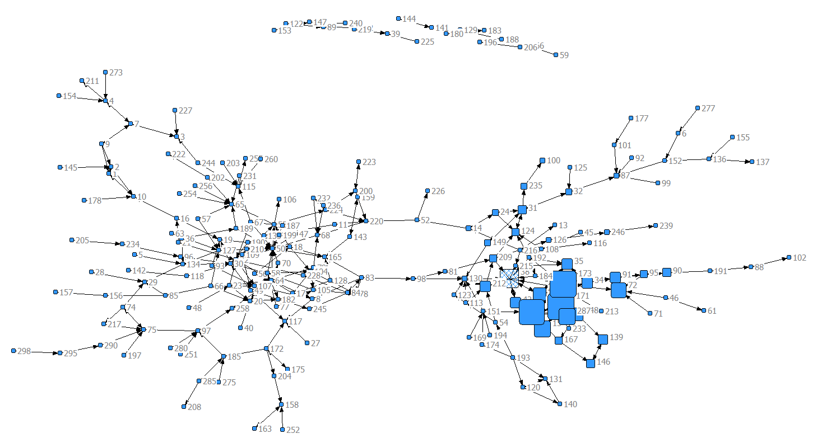

OutEigenvector centrality
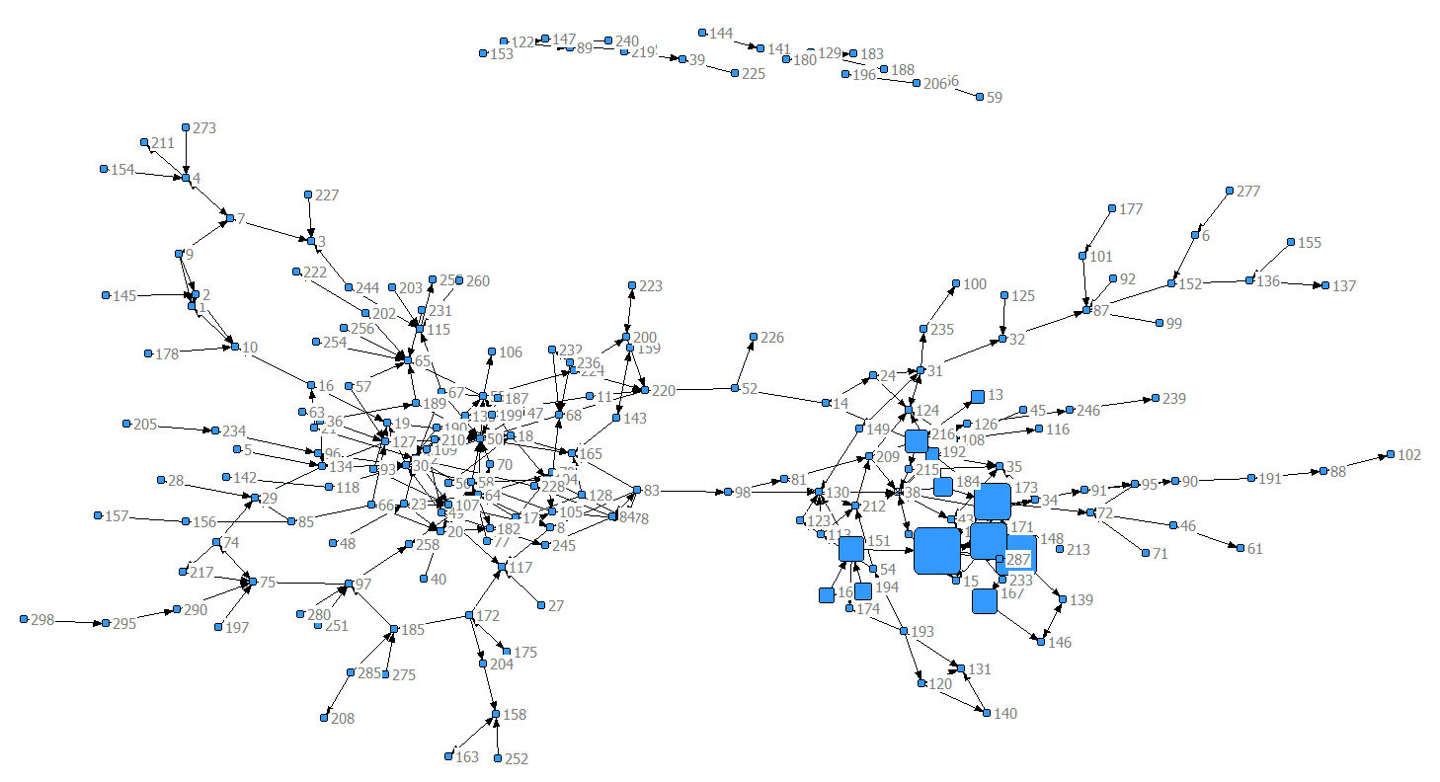

- In NetDraw, with DRUGNET already open, load the attribute file, DRUGATTR, by clicking on the folder with the A

- Calculate Centrality measures in NetDraw (remember that this is directed data)

- Using NetDraw color the nodes based on different attributes (e.g., gender, race) and size the nodes based on different Centrality measures. Do you see any patterns?

Indegree by gender
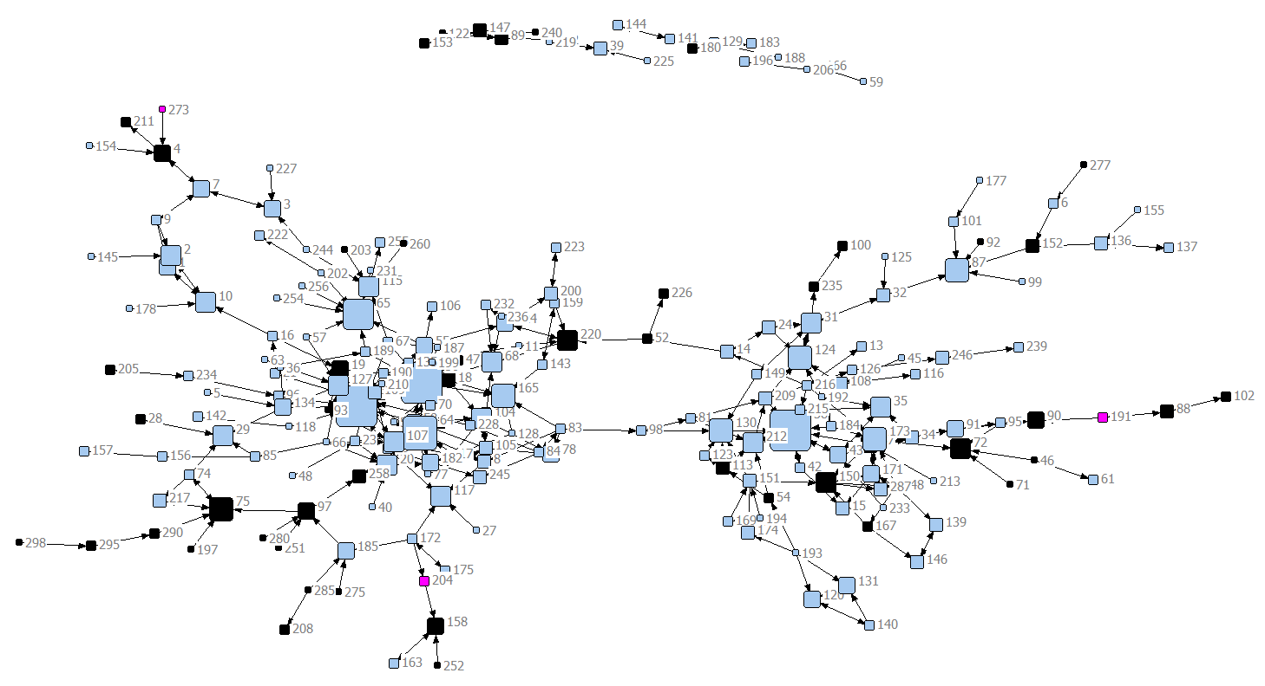

Outdegree by gender
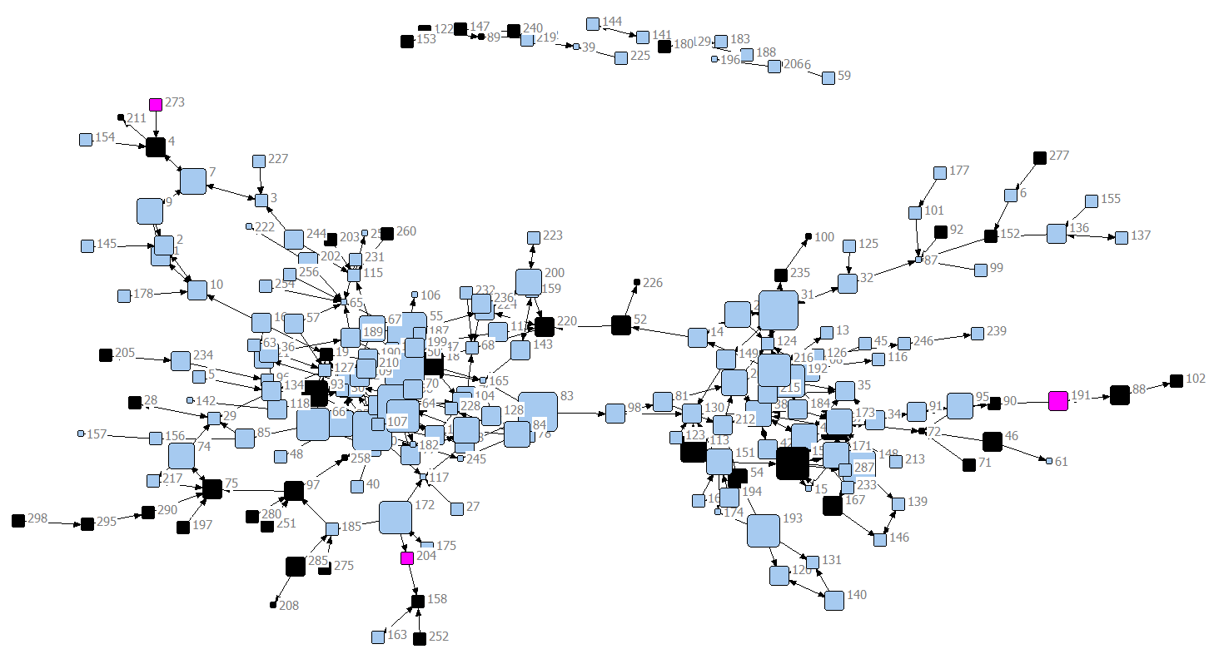

Indegree by ethnicity
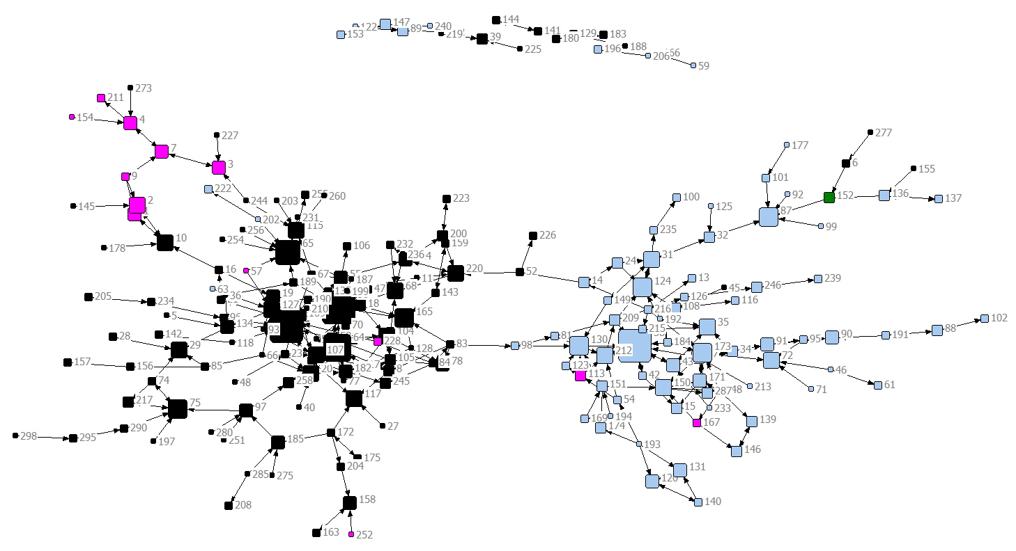

Outdegree by ethnicity
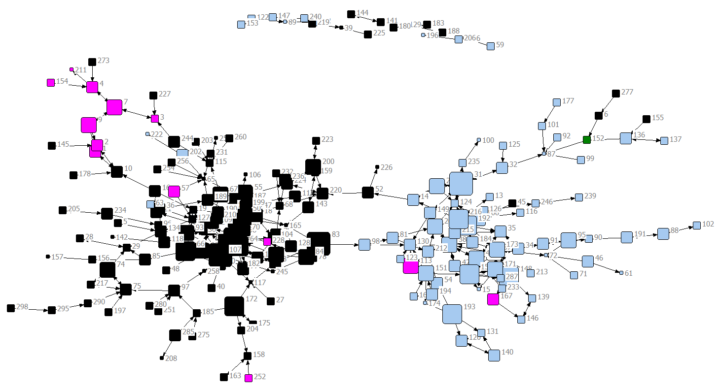
Interpretation: according two diagrams, people tend to share needles with people of same ethnicity (Homophily), and across genders, with a preponderance of one gender (indicated by squares)

