Cohesion Lab

For this lab we will use three sets of data:
CAMPNET:
This is a dichotomous adjacency matrix of 18 participants in a qualitative methods class. Ties are directed and represent that the ego indicated that the nominated alter was one of the three people with which s/he spent the most time during the seminar.
KAPTAIL:
This is a stacked dataset containing four dichotomous matrices. There are two adjacency matrices each for social ties (indicating the pair had social interaction) and instrumental ties (indicated the pair had work-related interaction). The two pairs of matrices represent two different points in time. The names of the datasets encode the type of tie in the sixth letter, and the time period in the seventh. Thus, the dataset KAPFTS1 is social ties at time 1 and KAPFTI2 is instrumental ties at time 2, etc.
ZACKAR & ZACHATTR:
ZACKAR is another stacked dataset, containing a dichotomous adjacency matrix, ZACHE, which represents the simple presence or absence of ties between members of a Karate Club, and ZACHC, which contains valued data counting the number of interactions between actors. ZACHATTR is a rectangular matrix with three columns of attributes for each of the actors from the ZACKAR datasets.

EXERCISES:
- Cohesion using UCINET with CAMPNET

a) Calculate the following measures of cohesion using Network | Cohesion
Density
Distance
Maximum Flow
Point Connectivity

Density = .176. This directed network has 18 nodes, so a maximum of 306 (N*N-1) ties could potentially exist. The actual number of ties in the network is 54. Density is calculated by dividing 54 by 306. (See output below.)

DENSITY / AVERAGE MATRIX VALUE
--------------------------------------------------------------------------------

Input dataset: campnet (C:\Users\Travis\Dropbox\UCINET Data Files\Datafiles\campnet)
Output dataset: campnet-density (C:\Users\Travis\Dropbox\UCINET Data Files\Datafiles\campnet-density)

1 2 3 4
Densit No. of Std De Avg De
y Ties v gree
------ ------ ------ ------
1 campnet 0.176 54 0.381 3

1 rows, 4 columns, 1 levels.

----------------------------------------

Distance:
Note: The output below calculates geodesic distance by replacing undefined distances with the total number of nodes (N) in the network. Since the number of nodes in the network is 18, the distance for all unreachable pairs is 18. You can also choose to represent unreachable pairs in other ways (i.e., as missing values or by the largest distance + 1). The decision you make here is likely to affect the values you get. If you wish, you can also choose to transform the values as reciprocal distances, which converts all measures of distance to measures of nearness.

The geodesic distance routine begins by calculating the geodesic distance between all pairs of nodes. In the “Frequencies” section below, we see the number of pairs that are various distances from one another. For example, there are 54 nodes that are directly tied to one another (i.e., a distance of 1) and there are 49 pairs that are 2 steps removed from one another. The proportion of pairs at each distance is also given in this section.

Based on the data in the frequencies section, an average geodesic distance and standard deviation for the graph is given.

The final piece of output contains an adjacency matrix with the geodesic distance between all pairs of nodes.

GEODESIC DISTANCES
--------------------------------------------------------------------------------

Input dataset: campnet (C:\Users\Travis\Dropbox\UCINET Data Files\Datafiles\campnet
Output dataset: campnet-geo (C:\Users\Travis\Dropbox\UCINET Data Files\Datafiles\campnet-geo
Transformation: No transformation
Undefined distances: N (number of nodes)

Frequencies

1 2
Freq Prop
------- -------
1 1 54 0.176
2 2 49 0.160
3 3 38 0.124
4 4 27 0.088
5 5 18 0.059
6 6 12 0.039
7 7 8 0.026
8 18 100 0.327

8 rows, 2 columns, 1 levels.

Average: 7.8
Std Dev: 7.2

1 2 3 4 5 6 7 8 9 10 11 12 13 14 15 16 17 18
HO BR CA PA PA JE PA AN MI BI LE DO JO HA GE ST BE RU
LL AZ RO M T NN UL N CH LL E N HN RR RY EV RT SS
Y EY L IE IN AE Y E
E L
-- -- -- -- -- -- -- -- -- -- -- -- -- -- -- -- -- --
1 HOLLY 0 18 2 1 1 2 2 2 2 18 18 1 18 2 18 18 18 18
2 BRAZEY 5 0 7 6 6 7 7 7 4 18 1 5 18 5 3 1 1 2
3 CAROL 2 18 0 1 1 2 1 2 4 18 18 3 18 4 18 18 18 18
4 PAM 3 18 2 0 2 1 1 1 5 18 18 4 18 5 18 18 18 18
5 PAT 1 18 1 2 0 1 2 2 3 18 18 2 18 3 18 18 18 18
6 JENNIE 2 18 2 1 1 0 2 1 4 18 18 3 18 4 18 18 18 18
7 PAULINE 2 18 1 1 1 2 0 2 4 18 18 3 18 4 18 18 18 18
8 ANN 3 18 2 1 2 1 1 0 5 18 18 4 18 5 18 18 18 18
9 MICHAEL 1 18 3 2 2 3 3 3 0 18 18 1 18 1 18 18 18 18
10 BILL 2 18 4 3 3 4 4 4 1 0 18 1 18 1 18 18 18 18
11 LEE 5 1 7 6 6 7 7 7 4 18 0 5 18 5 3 1 1 2
12 DON 1 18 3 2 2 3 3 3 1 18 18 0 18 1 18 18 18 18
13 JOHN 3 4 2 2 2 3 1 3 2 18 3 3 0 3 1 2 2 1
14 HARRY 1 18 3 2 2 3 3 3 1 18 18 1 18 0 18 18 18 18
15 GERY 2 3 4 3 3 4 4 4 1 18 2 2 18 2 0 1 2 1
16 STEVE 4 2 6 5 5 6 6 6 3 18 1 4 18 4 2 0 1 1
17 BERT 4 2 6 5 5 6 6 6 3 18 1 4 18 4 2 1 0 1
18 RUSS 3 3 5 4 4 5 5 5 2 18 2 3 18 3 1 1 1 0

18 rows, 18 columns, 1 levels.

--------------------------------------

See output for maximum flow and point connectivity below.

- Compare the point connectivity values and the maximum flow values. (Ignore values on the diagonal.) What is the relationship between them? Why do you think that is? Can you find the edge-independent paths (maximum flow) and node independent paths (point connectivity) between Bill and Pat by visualizing Campnet in NetDraw?

MAXIMUM FLOW
--------------------------------------------------------------------------------

Input dataset: campnet (C:\Users\Travis\Dropbox\UCINET Data Files\Datafiles\campnet)

1 1 1 1 1 1 1 1 1
1 2 3 4 5 6 7 8 9 0 1 2 3 4 5 6 7 8
H B C P P J P A M B L D J H G S B R
- - - - - - - - - - - - - - - - - -
1 HOLLY 0 0 2 2 2 2 2 2 1 0 0 1 0 1 0 0 0 0
2 BRAZEY 1 0 1 1 1 1 1 1 1 0 3 1 0 1 1 3 3 2
3 CAROL 1 0 0 3 3 3 3 2 1 0 0 1 0 1 0 0 0 0
4 PAM 1 0 2 0 3 3 3 2 1 0 0 1 0 1 0 0 0 0
5 PAT 1 0 2 3 0 3 3 2 1 0 0 1 0 1 0 0 0 0
6 JENNIE 1 0 2 3 3 0 3 2 1 0 0 1 0 1 0 0 0 0
7 PAULINE 1 0 2 3 3 3 0 2 1 0 0 1 0 1 0 0 0 0
8 ANN 1 0 2 3 3 3 3 0 1 0 0 1 0 1 0 0 0 0
9 MICHAEL 3 0 2 2 2 2 2 2 0 0 0 3 0 2 0 0 0 0
10 BILL 3 0 2 2 2 2 2 2 3 0 0 3 0 3 0 0 0 0
11 LEE 1 1 1 1 1 1 1 1 1 0 0 1 0 1 1 3 3 2
12 DON 3 0 2 2 2 2 2 2 2 0 0 0 0 2 0 0 0 0
13 JOHN 2 1 2 2 2 2 2 2 2 0 2 2 0 2 2 2 2 2
14 HARRY 3 0 2 2 2 2 2 2 2 0 0 3 0 0 0 0 0 0
15 GERY 1 1 1 1 1 1 1 1 1 0 2 1 0 1 0 2 2 2
16 STEVE 1 1 1 1 1 1 1 1 1 0 2 1 0 1 1 0 3 2
17 BERT 1 1 1 1 1 1 1 1 1 0 2 1 0 1 1 3 0 2
18 RUSS 1 1 1 1 1 1 1 1 1 0 2 1 0 1 1 3 3 0

Output actor-by-actor maximum flow matrix saved as dataset maximumflow

POINT CONNECTIVITY
--------------------------------------------------------------------------------

Input dataset: campnet (C:\Users\Travis\Dropbox\UCINET Data Files\Datafiles\campnet)
Output connectivity: PointConnectivity (C:\Users\Travis\Dropbox\UCINET Data Files\Datafiles\PointConnectivity)

1 1 1 1 1 1 1 1 1
1 2 3 4 5 6 7 8 9 0 1 2 3 4 5 6 7 8
H B C P P J P A M B L D J H G S B R
- - - - - - - - - - - - - - - - - -
1 HOLLY 0 0 2 2 2 2 2 2 1 0 0 1 0 1 0 0 0 0
2 BRAZEY 1 0 1 1 1 1 1 1 1 0 3 1 0 1 1 3 3 2
3 CAROL 1 0 0 3 3 2 3 2 1 0 0 1 0 1 0 0 0 0
4 PAM 1 0 2 0 2 3 3 2 1 0 0 1 0 1 0 0 0 0
5 PAT 1 0 2 3 0 2 3 2 1 0 0 1 0 1 0 0 0 0
6 JENNIE 1 0 2 3 2 0 3 2 1 0 0 1 0 1 0 0 0 0
7 PAULINE 1 0 2 3 3 2 0 2 1 0 0 1 0 1 0 0 0 0
8 ANN 1 0 2 3 2 3 3 0 1 0 0 1 0 1 0 0 0 0
9 MICHAEL 3 0 1 1 1 1 1 1 0 0 0 3 0 2 0 0 0 0
10 BILL 3 0 1 1 1 1 1 1 3 0 0 3 0 3 0 0 0 0
11 LEE 1 1 1 1 1 1 1 1 1 0 0 1 0 1 1 3 3 2
12 DON 3 0 1 1 1 1 1 1 2 0 0 0 0 2 0 0 0 0
13 JOHN 2 1 2 2 2 2 2 2 2 0 2 2 0 2 2 2 2 2
14 HARRY 3 0 1 1 1 1 1 1 2 0 0 3 0 0 0 0 0 0
15 GERY 1 1 1 1 1 1 1 1 1 0 2 1 0 1 0 2 2 2
16 STEVE 1 1 1 1 1 1 1 1 1 0 2 1 0 1 1 0 3 2
17 BERT 1 1 1 1 1 1 1 1 1 0 2 1 0 1 1 3 0 2
18 RUSS 1 1 1 1 1 1 1 1 1 0 2 1 0 1 1 3 2 0

Output actor-by-actor point connectivity matrix saved as dataset PointConnectivity

----------------------------------------

You should notice that these two matrices are very similar (the correlation between them is .955). This is because when we look at each dyad in the two matrices it is often the case that the number of edge independent paths and the number of node independent paths that connect them are highly correlated. For example, the number of edge independent paths from Holly to Carol is 2 and the number of node independent paths between from Holly to Carol is also 2.

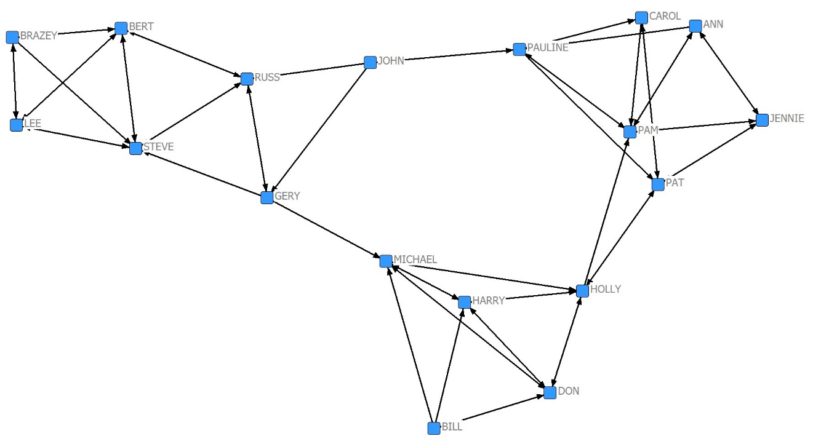
When you examine the diagram above, you should find that the maximum flow from Bill to Pat is 2 while the point connectivity is only 1. This is because only one node (Holly) needs to be removed for Bill to not be able to reach Pat, but two ties (HollyPat; HollyPam) must be removed. (Remember that this is a directed graph so the directionality of ties matters!) Remember the Fun Fact For Math Geeks… Point Connectivity for any dyad MUST be less than or equal to Edge Connectivity (Maximum Flow) for those same two nodes.

- Using your Netdraw visualization, verify a couple entries in the distance matrix produced (Campnet-Geo)

You should find, for example, that the geodesic distance from Holly to Carol is 2 and the geodesic distance from Bill to Gery is undefined (or 18 in the distance output above) because there is no path by which Bill can reach Gery (again, remember that the direction of the arrows matters).
- Average Degree & Centralization using KAPTAIL

- Run Network | Centrality | Degree on KAPTAIL. This will generate results for all four networks (matrices, levels) in the dataset. First it will show you node level data for each of the four networks, then appropriate centralization scores for the appropriate measures in each of the four networks. Why are there some zeroes in the Centralization scores? (Hint: Look at those measures for those networks in the previous output.)

You should get the following output, with node-level raw and normalized degree scores followed by graph centralization scores at the bottom:

FREEMAN DEGREE CENTRALITY
--------------------------------------------------------------------------------

Input dataset: kaptail (C:\Program Files\Analytic Technologies\Datafiles\kaptail
Output degree dataset: kaptail-deg (C:\Program Files\Analytic Technologies\Datafiles\kaptail-deg
Output centralization dataset: kaptail-degcz (C:\Program Files\Analytic Technologies\Datafiles\kaptail-degcz
Treat data as: Auto-detect
Output raw scores: YES
Output normalized scores: YES
Allow edge weights: YES
Exclude diagonal: YES

Network KAPFTS1 is directed? NO
Network KAPFTS2 is directed? NO
Network KAPFTI1 is directed? YES
Network KAPFTI2 is directed? YES

Degree Measures

Matrix: KAPFTS1

1 2 3 4 5 6
Degree nDegre Outdeg Indeg nOutde nIndeg
e g
------ ------ ------ ------ ------ ------
1 KAMWEFU 4.000 0.105 0.000 0.000
2 NKUMBULA 5.000 0.132 0.000 0.000
3 ABRAHAM 13.000 0.342 0.000 0.000
4 SEAMS 9.000 0.237 0.000 0.000
5 CHIPATA 5.000 0.132 0.000 0.000
6 DONALD 6.000 0.158 0.000 0.000
7 NKOLOYA 6.000 0.158 0.000 0.000
8 MATEO 3.000 0.079 0.000 0.000
9 CHILWA 9.000 0.237 0.000 0.000
10 CHIPALO 1.000 0.026 0.000 0.000
11 LYASHI 15.000 0.395 0.000 0.000
12 ZULU 14.000 0.368 0.000 0.000
13 HASTINGS 10.000 0.263 0.000 0.000
14 LWANGA 8.000 0.211 0.000 0.000
15 NYIRENDA 5.000 0.132 0.000 0.000
16 CHISOKONE 24.000 0.632 0.000 0.000
17 ENOCH 2.000 0.053 0.000 0.000
18 PAULOS 7.000 0.184 0.000 0.000
19 MUKUBWA 17.000 0.447 0.000 0.000
20 SIGN 1.000 0.026 0.000 0.000
21 KALAMBA 8.000 0.211 0.000 0.000
22 ZAKEYO 1.000 0.026 0.000 0.000
23 BEN 7.000 0.184 0.000 0.000
24 IBRAHIM 11.000 0.289 0.000 0.000
25 MESHAK 4.000 0.105 0.000 0.000
26 ADRIAN 2.000 0.053 0.000 0.000
27 KALUNDWE 5.000 0.132 0.000 0.000
28 MPUNDU 9.000 0.237 0.000 0.000
29 JOHN 9.000 0.237 0.000 0.000
30 JOSEPH 10.000 0.263 0.000 0.000
31 WILLIAM 10.000 0.263 0.000 0.000
32 HENRY 14.000 0.368 0.000 0.000
33 CHOBE 10.000 0.263 0.000 0.000
34 MUBANGA 14.000 0.368 0.000 0.000
35 CHRISTIAN 8.000 0.211 0.000 0.000
36 KALONGA 10.000 0.263 0.000 0.000
37 ANGEL 6.000 0.158 0.000 0.000
38 CHILUFYA 9.000 0.237 0.000 0.000
39 MABANGE 5.000 0.132 0.000 0.000

Matrix: KAPFTS2

1 2 3 4 5 6
Degree nDegre Outdeg Indeg nOutde nIndeg
e g
------ ------ ------ ------ ------ ------
1 KAMWEFU 12.000 0.316 0.000 0.000
2 NKUMBULA 12.000 0.316 0.000 0.000
3 ABRAHAM 17.000 0.447 0.000 0.000
4 SEAMS 3.000 0.079 0.000 0.000
5 CHIPATA 14.000 0.368 0.000 0.000
6 DONALD 2.000 0.053 0.000 0.000
7 NKOLOYA 14.000 0.368 0.000 0.000
8 MATEO 6.000 0.158 0.000 0.000
9 CHILWA 9.000 0.237 0.000 0.000
10 CHIPALO 7.000 0.184 0.000 0.000
11 LYASHI 19.000 0.500 0.000 0.000
12 ZULU 14.000 0.368 0.000 0.000
13 HASTINGS 18.000 0.474 0.000 0.000
14 LWANGA 12.000 0.316 0.000 0.000
15 NYIRENDA 8.000 0.211 0.000 0.000
16 CHISOKONE 22.000 0.579 0.000 0.000
17 ENOCH 8.000 0.211 0.000 0.000
18 PAULOS 9.000 0.237 0.000 0.000
19 MUKUBWA 25.000 0.658 0.000 0.000
20 SIGN 2.000 0.053 0.000 0.000
21 KALAMBA 16.000 0.421 0.000 0.000
22 ZAKEYO 7.000 0.184 0.000 0.000
23 BEN 7.000 0.184 0.000 0.000
24 IBRAHIM 21.000 0.553 0.000 0.000
25 MESHAK 18.000 0.474 0.000 0.000
26 ADRIAN 10.000 0.263 0.000 0.000
27 KALUNDWE 4.000 0.105 0.000 0.000
28 MPUNDU 11.000 0.289 0.000 0.000
29 JOHN 13.000 0.342 0.000 0.000
30 JOSEPH 16.000 0.421 0.000 0.000
31 WILLIAM 10.000 0.263 0.000 0.000
32 HENRY 12.000 0.316 0.000 0.000
33 CHOBE 10.000 0.263 0.000 0.000
34 MUBANGA 16.000 0.421 0.000 0.000
35 CHRISTIAN 9.000 0.237 0.000 0.000
36 KALONGA 12.000 0.316 0.000 0.000
37 ANGEL 6.000 0.158 0.000 0.000
38 CHILUFYA 9.000 0.237 0.000 0.000
39 MABANGE 6.000 0.158 0.000 0.000

Matrix: KAPFTI1

1 2 3 4 5 6
Degree nDegre Outdeg Indeg nOutde nIndeg
e g
------ ------ ------ ------ ------ ------
1 KAMWEFU 1.000 3.000 0.026 0.079
2 NKUMBULA 1.000 2.000 0.026 0.053
3 ABRAHAM 8.000 9.000 0.211 0.237
4 SEAMS 1.000 3.000 0.026 0.079
5 CHIPATA 1.000 1.000 0.026 0.026
6 DONALD 1.000 2.000 0.026 0.053
7 NKOLOYA 4.000 2.000 0.105 0.053
8 MATEO 0.000 0.000 0.000 0.000
9 CHILWA 2.000 5.000 0.053 0.132
10 CHIPALO 0.000 0.000 0.000 0.000
11 LYASHI 9.000 8.000 0.237 0.211
12 ZULU 7.000 4.000 0.184 0.105
13 HASTINGS 3.000 2.000 0.079 0.053
14 LWANGA 5.000 2.000 0.132 0.053
15 NYIRENDA 3.000 3.000 0.079 0.079
16 CHISOKONE 12.000 6.000 0.316 0.158
17 ENOCH 1.000 1.000 0.026 0.026
18 PAULOS 0.000 0.000 0.000 0.000
19 MUKUBWA 12.000 2.000 0.316 0.053
20 SIGN 1.000 2.000 0.026 0.053
21 KALAMBA 2.000 2.000 0.053 0.053
22 ZAKEYO 2.000 0.000 0.053 0.000
23 BEN 1.000 3.000 0.026 0.079
24 IBRAHIM 4.000 5.000 0.105 0.132
25 MESHAK 2.000 0.000 0.053 0.000
26 ADRIAN 0.000 0.000 0.000 0.000
27 KALUNDWE 1.000 3.000 0.026 0.079
28 MPUNDU 1.000 4.000 0.026 0.105
29 JOHN 3.000 4.000 0.079 0.105
30 JOSEPH 3.000 4.000 0.079 0.105
31 WILLIAM 0.000 2.000 0.000 0.053
32 HENRY 5.000 7.000 0.132 0.184
33 CHOBE 1.000 2.000 0.026 0.053
34 MUBANGA 4.000 4.000 0.105 0.105
35 CHRISTIAN 1.000 3.000 0.026 0.079
36 KALONGA 1.000 2.000 0.026 0.053
37 ANGEL 3.000 4.000 0.079 0.105
38 CHILUFYA 1.000 1.000 0.026 0.026
39 MABANGE 2.000 2.000 0.053 0.053

Matrix: KAPFTI2

1 2 3 4 5 6
Degree nDegre Outdeg Indeg nOutde nIndeg
e g
------ ------ ------ ------ ------ ------
1 KAMWEFU 5.000 2.000 0.132 0.053
2 NKUMBULA 4.000 4.000 0.105 0.105
3 ABRAHAM 10.000 10.000 0.263 0.263
4 SEAMS 2.000 2.000 0.053 0.053
5 CHIPATA 9.000 8.000 0.237 0.211
6 DONALD 1.000 1.000 0.026 0.026
7 NKOLOYA 7.000 8.000 0.184 0.211
8 MATEO 4.000 3.000 0.105 0.079
9 CHILWA 2.000 3.000 0.053 0.079
10 CHIPALO 2.000 2.000 0.053 0.053
11 LYASHI 21.000 12.000 0.553 0.316
12 ZULU 5.000 3.000 0.132 0.079
13 HASTINGS 5.000 3.000 0.132 0.079
14 LWANGA 5.000 5.000 0.132 0.132
15 NYIRENDA 2.000 2.000 0.053 0.053
16 CHISOKONE 10.000 4.000 0.263 0.105
17 ENOCH 3.000 4.000 0.079 0.105
18 PAULOS 2.000 2.000 0.053 0.053
19 MUKUBWA 7.000 3.000 0.184 0.079
20 SIGN 1.000 3.000 0.026 0.079
21 KALAMBA 2.000 4.000 0.053 0.105
22 ZAKEYO 0.000 2.000 0.000 0.053
23 BEN 2.000 1.000 0.053 0.026
24 IBRAHIM 6.000 8.000 0.158 0.211
25 MESHAK 6.000 2.000 0.158 0.053
26 ADRIAN 0.000 0.000 0.000 0.000
27 KALUNDWE 0.000 0.000 0.000 0.000
28 MPUNDU 2.000 5.000 0.053 0.132
29 JOHN 2.000 7.000 0.053 0.184
30 JOSEPH 2.000 5.000 0.053 0.132
31 WILLIAM 1.000 2.000 0.026 0.053
32 HENRY 4.000 5.000 0.105 0.132
33 CHOBE 2.000 2.000 0.053 0.053
34 MUBANGA 6.000 7.000 0.158 0.184
35 CHRISTIAN 1.000 2.000 0.026 0.053
36 KALONGA 1.000 3.000 0.026 0.079
37 ANGEL 2.000 6.000 0.053 0.158
38 CHILUFYA 0.000 1.000 0.000 0.026
39 MABANGE 1.000 1.000 0.026 0.026

39 rows, 6 columns, 4 levels.

Graph Centralization -- as proportion, not percentage

1 2 3
Degree Outdeg Indeg
------ ------ ------
1 KAPFTS1 0.4410 0.0000 0.0000
2 KAPFTS2 0.3762 0.0000 0.0000
3 KAPFTI1 0.0000 0.2486 0.1676
4 KAPFTI2 0.0000 0.4654 0.2223

4 rows, 3 columns, 1 levels.

You will see that there are some zeros in the Graph Centralization section. This is because UCINET automatically determines whether each graph is directed or not and calculates degree & centralization accordingly. For example, KAPFTS1 is not directed, so we only see values in the Degree and nDegree columns (and nothing in the Outdeg and Indeg columns). Accordingly, the centralization score for KAPFTS1 is .4410 for Degree and 0 for both Outdeg and Indeg. KAPFTI1, on the other hand, is directed. We therefore get Indeg and Oudeg values for the graph and no values in the Degree column. Consequently, we get Outdeg (.2486) and Indeg (.1676) centralization scores for KAPFTI1 and a 0 for Degree.
(BTW: The nDegree column is just a normalized measure of Degree. We will discuss that Wednesday afternoon, but, in general, just ignore the measures with the “n” before then.)

- To find average degree, you can run descriptive statistics on the node level data. By default running degree centrality created a dataset called KAPTAIL-deg with the node level degree measures for it (and another one called KAPTAIL-degcz for the centralization scores). Use the menu Tools | Univariate statistics to run Univariate statistics on the degree scores by node and find the appropriate average degree scores.

Be sure to select “columns” as the dimensions to analyze. You should get the following output:

UNIVARIATE STATISTICS
--------------------------------------------------------------------------------

Input dataset: kaptail-deg (C:\Users\Travis\Documents\UCINET data\kaptail-deg
Output dataset: kaptail-deg-uni (C:\Users\Travis\Documents\UCINET data\kaptail-deg-uni
Dimension to analyze: Columns
Diagonal valid: YES

Statistics

1 2 3 4 5 6
Degree nDegree Outdeg Indeg nOutdeg nIndeg
-------- -------- -------- -------- -------- --------
1 Observations 39 39 0 0 39 39
2 Missing 0 0 39 39 0 0
3 Minimum 1 0.026 0 0
4 Maximum 24 0.632 0 0
5 Sum 316 8.316 0 0
6 Average 8.103 0.213 0 0
7 SSQ 3448 2.388 0 0
8 Standard Deviation 4.771 0.126 0 0
9 Variance 22.759 0.016 0 0
10 MCSSQ 887.590 0.615 0 0
11 Euclidean Norm 58.720 1.545 0 0

11 rows, 6 columns, 1 levels.

Statistics

1 2 3 4 5 6
Degree nDegree Outdeg Indeg nOutdeg nIndeg
-------- -------- -------- -------- -------- --------
1 Observations 39 39 0 0 39 39
2 Missing 0 0 39 39 0 0
3 Minimum 2 0.053 0 0
4 Maximum 25 0.658 0 0
5 Sum 446 11.737 0 0
6 Average 11.436 0.301 0 0
7 SSQ 6254 4.331 0 0
8 Standard Deviation 5.439 0.143 0 0
9 Variance 29.579 0.020 0 0
10 MCSSQ 1153.590 0.799 0 0
11 Euclidean Norm 79.082 2.081 0 0

11 rows, 6 columns, 1 levels.

Statistics

1 2 3 4 5 6
Degree nDegree Outdeg Indeg nOutdeg nIndeg
------- ------- ------- ------- ------- -------
1 Observations 0 0 39 39 39 39
2 Missing 39 39 0 0 0 0
3 Minimum 0 0 0 0
4 Maximum 12 9 0.316 0.237
5 Sum 109 109 2.868 2.868
6 Average 2.795 2.795 0.074 0.074
7 SSQ 659 481 0.456 0.333
8 Standard Deviation 3.014 2.127 0.079 0.056
9 Variance 9.086 4.522 0.006 0.003
10 MCSSQ 354.359 176.359 0.245 0.122
11 Euclidean Norm 25.671 21.932 0.676 0.577

11 rows, 6 columns, 1 levels.

Statistics

1 2 3 4 5 6
Degree nDegree Outdeg Indeg nOutdeg nIndeg
-------- -------- -------- -------- -------- --------
1 Observations 0 0 39 39 39 39
2 Missing 39 39 0 0 0 0
3 Minimum 0 0 0 0
4 Maximum 21 12 0.553 0.316
5 Sum 147 147 3.868 3.868
6 Average 3.769 3.769 0.099 0.099
7 SSQ 1139 841 0.789 0.582
8 Standard Deviation 3.873 2.712 0.102 0.071
9 Variance 14.998 7.357 0.010 0.005
10 MCSSQ 584.923 286.923 0.405 0.199
11 Euclidean Norm 33.749 29 0.888 0.763

11 rows, 6 columns, 1 levels.
As you can see, the average degree centrality in the KAPFTS1 (the first set of output) is 8.103. As you also probably noticed, the univariate statistics routine can calculate a number of other statistics besides average….

- Compare the results for KAPFTS1 and KAPTFTS2 (the social ties at time 1 and time 2). What happened to average degree? What happened to network centralization? Does this make sense?

Average degree increased from 8.103 to 11.436. At the same time, centralization decreased from .441 to .376. What this tells us is that, on average, people added social ties between time 1 and time 2, and the ties that they added tended to be to people who were less central in the network. Centralization decreased as the average number of ties increased. In other words, the additional social ties added between time 1 and time 2 made the network more diffuse instead of more centralized. To see this graphically look at the visualizations on the next page. See, for example, how people who were on the periphery of the network at time 1 (e.g., Chipalo, Enoch, Zakeyo) gain many ties at time 2.

KAPFTS1

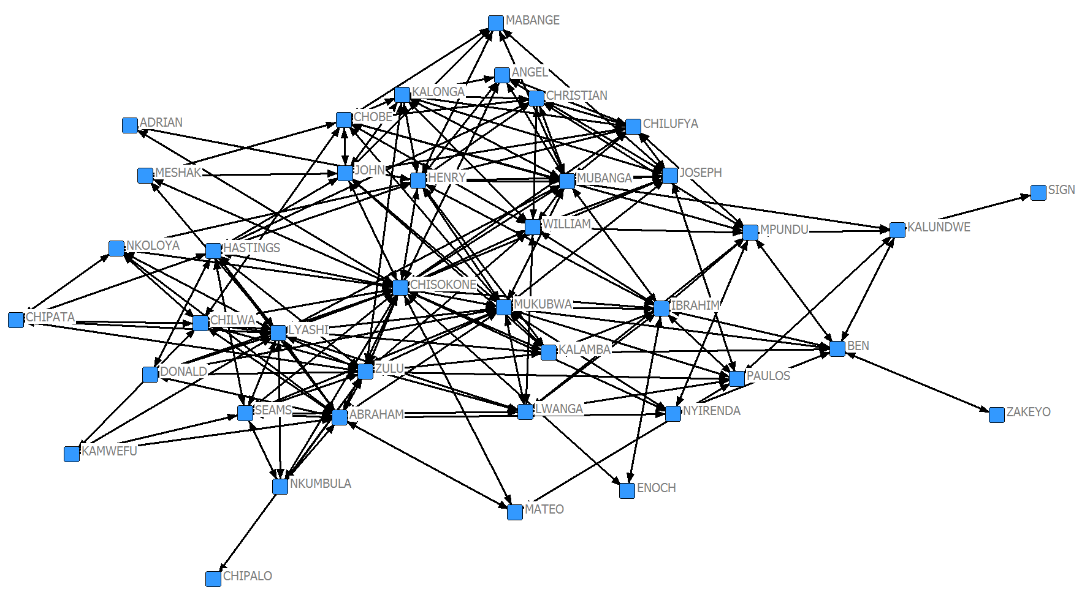

KAPFTS2

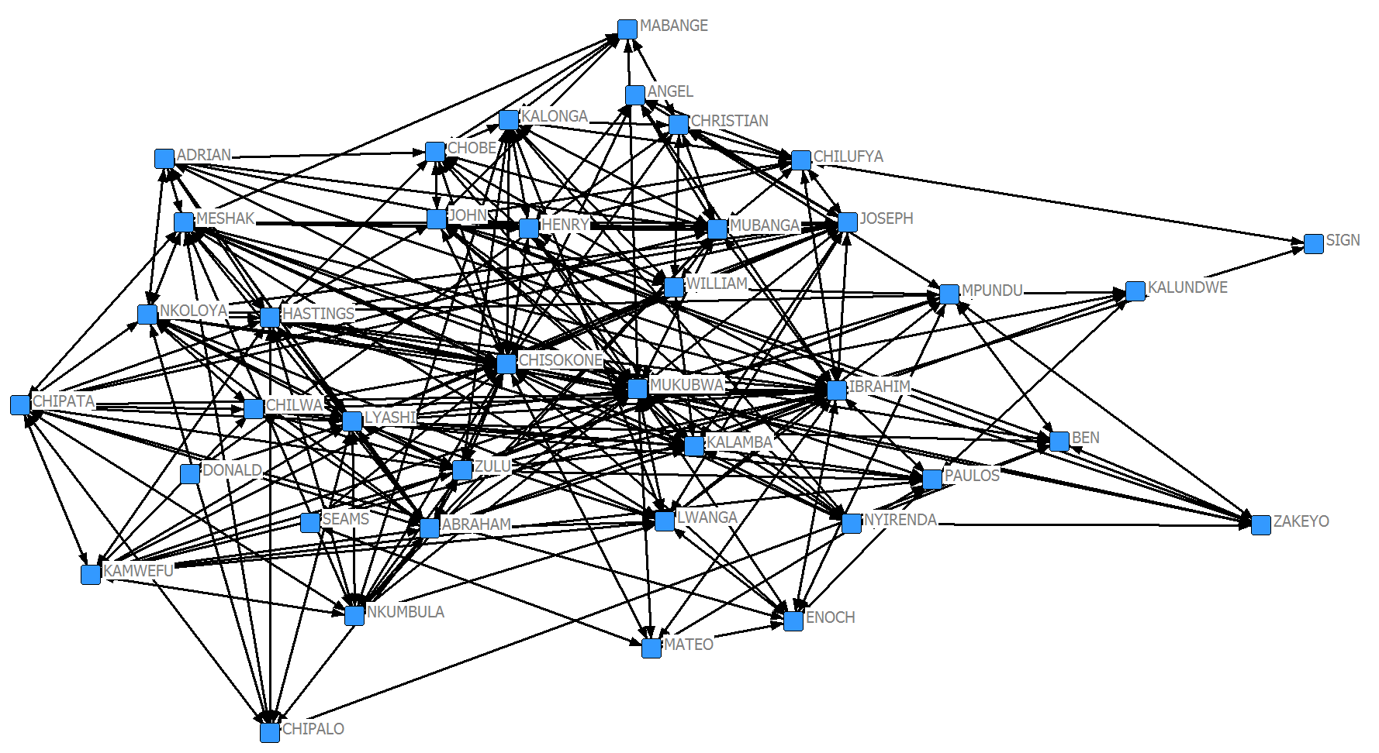

- Compare the results for KAPFTI1 and KAPFTI2 (the instrumental/work ties at time 1 and time 2). What happened to average degree and centralization here? Does this make sense? Why do you think the results differ across type of relationships?

We see that the average number of outgoing instrumental ties increased from 2.795 at time 1 to 3.769 at time 2. The outdegree centralization in this network also increased from .2486 to .4654. People also added ties in this network, but they tended to add ties to others who were already in central positions. The instrumental tie network therefore became more centralized over time instead of becoming more diffuse. This highlights a potential difference between social ties and instrumental ties. Social ties appear to be distributed in a more “democratic” way, whereas instrumental ties are distributed in a centralized manner. One possible explanation for this is that individuals tend to form social ties based on homophily, but people form instrumental ties with prominent experts in the organization. Thus, while social ties are widely distributed based on who is similar to whom, instrumental ties become focused on the relatively few prominent experts in the network.
- Fragmentation using UCINET and KAPTAIL
  - Using the KAPFTS1 dataset (you may have to unpack KAPTAIL if you have not already done so using Data | Unpack), calculate its fragmentation under Network | Centrality using the default options. This reports both “Fragmentation” and “Distance Weighted Fragmentation.” Why are the numbers different? Which one is more useful for this network? When would you choose to use one or the other?

FRAGMENTATION CENTRALITY
--------------------------------------------------------------------------------

Input network: KAPFTS1 (C:\Users\Travis\Documents\UCINET data\KAPFTS1)
Output measures: Fragmentation (C:\Users\Travis\Documents\UCINET data\Fragmentation)
Method: Removal

NOTE: This procedure binarizes but does NOT symmetrize data.

Network Fragmentation Prior to Removing Any Nodes

Fragmentation: 0.000
Distance-Weighted Fragmentation: 0.433

Fragmentation for KAPFTS1 is 0.0. This is because the network is composed of one component (i.e., all nodes are connected). The normal fragmentation measure is not particularly useful in a connected network. The distance-weighted fragmentation (.433), however, is more useful because it is one minus the average reciprocal distance between all pairs of nodes. Distance-weighted fragmentation therefore provides a more nuanced measure of that is useful even for connected networks. Distance-weighted fragmentation is particularly useful if the network relationship attenuates with distance (e.g., the value of gossip deteriorates as distance grows since the gossip is no longer “fresh” by the time it travels multiple steps). The regular fragmentation measure is more useful in networks that consist of multiple components or in applications in which distance does not attenuate the quality of the relationship (e.g., digital copies of software are perfect no matter how many people they pass through, so the effects of software piracy may be better modeled with fragmentation instead of distance weighted fragmentation).

  - Based on the results from Exercise 2 above, what do you think will happen to each of the fragmentation measures if you run them for KAPFTS2. Run them to check your answers. Were you surprised? By which measure(s)? Why are the results what they are?

FRAGMENTATION CENTRALITY
--------------------------------------------------------------------------------

Input network: KAPFTS2 (C:\Users\Travis\Documents\UCINET data\KAPFTS2)
Output measures: Fragmentation (C:\Users\Travis\Documents\UCINET data\Fragmentation)
Method: Removal

NOTE: This procedure binarizes but does NOT symmetrize data.

Network Fragmentation Prior to Removing Any Nodes

Fragmentation: 0.000
Distance-Weighted Fragmentation: 0.362
The fragmentation value for KAPFTS2 is also 0.0 because the network is connected (i.e., one component). The distance-weighted fragmentation value decreased to .362. This shouldn’t be too surprising since we already know that the number of ties in this network increased between time 1 and time 2 and the new ties were relatively well distributed throughout the network. Thus, it makes sense that fragmentation decreased.

  - Running Fragmentation also gives you node level scores. We did not cover this in the lecture, but what do you think this may mean? (For a hint, go back to the dialog box for running Fragmentation and look at the option given.)

The node-level fragmentation scores tell us how much the fragmentation score goes up when a given node is removed from the network. In other words, it tells us how much each node contributes to non-fragmentation in the network. In the partial output from KAPFTS2 below, we see that the distance-weighted fragmentation of the network goes up to .363 (column 2) when Kamwefu is removed from the network. This equates to a .001 change (column 4) in distance-weighted fragmentation when this node is removed. The percentage change that this represents is found in column 6.

Node-Level Fragmentation Measures

1 2 3 4 5 6
Frag DwFrag FragDif DwFragD PctFrag PctDwFr
------- ------- ------- ------- ------- -------
1 KAMWEFU 0.000 0.363 0.000 0.001 0.000 0.002

- Core-Periphery using UCINET with KAPTAIL
  - Run Network | Core/Periphery | Categorical on KAPFTS1 and KAPFTS2. How do the results differ? During which time period was there a more clear core/periphery structure to the social ties? What happened to the core between time 1 and time 2?

KAPFTS1 Output (keep all options to their default settings):

SIMPLE CORE/PERIPHERY MODEL
--------------------------------------------------------------------------------

Input dataset: KAPFTS1 (C:\Users\Travis\Documents\UCINET data\KAPFTS1)
Type of data: Positive
Fitness measure: CORR
Density of core-to-periphery ties:
Number of iterations: 50
Population size: 100
Output partition: CorePartition (C:\Users\Travis\Documents\UCINET data\CorePartition)
Output clusters: CoreClasses (C:\Users\Travis\Documents\UCINET data\CoreClasses)

Starting fitness: 0.482
Final fitness: 0.486

Core/Periphery Class Memberships:

1: ABRAHAM SEAMS LYASHI ZULU HASTINGS CHISOKONE MUKUBWA IBRAHIM JOSEPH WILLIAM HENRY CHOBE MUBANGA KALONGA CHILUFYA
2: KAMWEFU NKUMBULA CHIPATA DONALD NKOLOYA MATEO CHILWA CHIPALO LWANGA NYIRENDA ENOCH PAULOS SIGN KALAMBA ZAKEYO BEN MESHAK ADRIAN KALUNDWE MPUNDU JOHN CHRISTIAN ANGEL MABANGE

Density matrix

1 2
----- -----
1 0.514 0.228
2 0.228 0.080
KAPFTS2 Output:

SIMPLE CORE/PERIPHERY MODEL
--------------------------------------------------------------------------------

Input dataset: KAPFTS2 (C:\Users\Travis\Documents\UCINET data\KAPFTS2)
Type of data: Positive
Fitness measure: CORR
Density of core-to-periphery ties:
Number of iterations: 50
Population size: 100
Output partition: CorePartition (C:\Users\Travis\Documents\UCINET data\CorePartition)
Output clusters: CoreClasses (C:\Users\Travis\Documents\UCINET data\CoreClasses)

Starting fitness: 0.548
Final fitness: 0.548

Core/Periphery Class Memberships:

1: KAMWEFU NKUMBULA ABRAHAM CHIPATA NKOLOYA LYASHI ZULU HASTINGS CHISOKONE MUKUBWA KALAMBA IBRAHIM MESHAK JOSEPH MUBANGA
2: SEAMS DONALD MATEO CHILWA CHIPALO LWANGA NYIRENDA ENOCH PAULOS SIGN ZAKEYO BEN ADRIAN KALUNDWE MPUNDU JOHN WILLIAM HENRY CHOBE CHRISTIAN KALONGA ANGEL CHILUFYA MABANGE

Density matrix

1 2
----- -----
1 0.752 0.267
2 0.267 0.174

First, we see that the model fitness increased from .486 to .548 between time 1 and time 2, so the time 2 network has more of a core/periphery structure to it. Second, we can see that there were 15 people in the core at each time period.

- Core members at time 1: ABRAHAM SEAMS LYASHI ZULU HASTINGS CHISOKONE MUKUBWA IBRAHIM JOSEPH WILLIAM HENRY CHOBE MUBANGA KALONGA CHILUFYA

- Core members at time 2: KAMWEFU NKUMBULA ABRAHAM CHIPATA NKOLOYA LYASHI ZULU HASTINGS CHISOKONE MUKUBWA KALAMBA IBRAHIM MESHAK JOSEPH MUBANGA

Upon inspection of the core membership at each time period, we can conclude that there was some churn in core membership. Some individuals were members at time 1 but not time 2 (e.g., Seams, William, Henry, Chobe, Kalonga, & Chilufa). Conversely, there were some individuals who were on the periphery at time 1 but in the core at time 2 (e.g., Kamwefu, Nkumbula, Chipata, Nkoloya, etc…).

Third, we can see that the density of ties within the core increased from .514 to .752 (see the Density Matrix at each time point).

  - Run Network | Core/Periphery | Continuous on KAPFTS1. Find the line where it recommends how many nodes should be in the core. Does that match the size of the core found from the Categorical procedure? How might you determine which one better captures the core/periphery nature of the data?

Output (keeping all options at their default settings):

CONTINUOUS CORENESS MODEL
--------------------------------------------------------------------------------

Input dataset: KAPFTS1 (C:\Users\Travis\Documents\UCINET data\KAPFTS1)
Algorithm MINRES

Multiplicative Coreness

1
Corene
------
16 CHISOKONE 0.409
19 MUKUBWA 0.290
11 LYASHI 0.255
32 HENRY 0.238
12 ZULU 0.238
34 MUBANGA 0.238
3 ABRAHAM 0.221
24 IBRAHIM 0.187
31 WILLIAM 0.170
33 CHOBE 0.170
13 HASTINGS 0.170
36 KALONGA 0.170
30 JOSEPH 0.170
29 JOHN 0.153
38 CHILUFYA 0.153
4 SEAMS 0.153
9 CHILWA 0.153
28 MPUNDU 0.153
21 KALAMBA 0.136
35 CHRISTIAN 0.136
14 LWANGA 0.136
23 BEN 0.119
18 PAULOS 0.119
7 NKOLOYA 0.102
6 DONALD 0.102
37 ANGEL 0.102
15 NYIRENDA 0.085
5 CHIPATA 0.085
39 MABANGE 0.085
27 KALUNDWE 0.085
2 NKUMBULA 0.085
1 KAMWEFU 0.068
25 MESHAK 0.068
8 MATEO 0.051
26 ADRIAN 0.034
17 ENOCH 0.034
22 ZAKEYO 0.017
10 CHIPALO 0.017
20 SIGN 0.017

Descriptive Statistics
1
Corene
------
1 Mean 0.138
2 Std Dev 0.081
3 Sum 5.382
4 Variance 0.007
5 SSQ 1.000
6 MCSSQ 0.257
7 Euc Norm 1.000
8 Minimum 0.017
9 Maximum 0.409
10 N of Obs 39.000
11 N Missing 0.000

Correlation: 0.445

Gini Coefficient: 0.320
Composite "gini-based core/peripheriness": 0.142
Heterogeneity: 0.009

Concentration scores for different sizes of core

1 2 3 4 5 6 7
Diff nDiff Corr Ident CoreDen PerDen DenDiff
-------- -------- -------- -------- -------- -------- --------
1 0.507 0.507 0.541 0.313 0.191
2 0.328 0.463 0.604 0.458 1.000 0.177 0.823
3 0.271 0.469 0.639 0.549 1.000 0.167 0.833
4 0.228 0.455 0.666 0.611 0.833 0.156 0.677
5 0.217 0.485 0.699 0.661 0.800 0.146 0.654
6 0.233 0.571 0.736 0.702 0.800 0.136 0.664
7 0.249 0.659 0.760 0.729 0.762 0.127 0.635
8 0.217 0.614 0.761 0.740 0.714 0.120 0.594
9 0.186 0.557 0.754 0.743 0.667 0.115 0.552
10 0.178 0.564 0.751 0.745 0.600 0.106 0.494
11 0.173 0.574 0.751 0.748 0.582 0.101 0.481
12 0.169 0.587 0.754 0.750 0.561 0.094 0.467
13 0.189 0.681 0.760 0.752 0.551 0.089 0.462
14 0.164 0.612 0.757 0.749 0.527 0.083 0.444
15 0.161 0.624 0.756 0.746 0.514 0.080 0.435
16 0.160 0.639 0.758 0.744 0.500 0.075 0.425
17 0.159 0.657 0.762 0.742 0.471 0.061 0.410
18 0.181 0.769 0.767 0.740 0.444 0.043 0.402
19 0.159 0.691 0.764 0.734 0.439 0.042 0.396
20 0.158 0.708 0.763 0.729 0.437 0.047 0.390
21 0.181 0.828 0.764 0.725 0.429 0.046 0.383
22 0.158 0.742 0.756 0.717 0.407 0.029 0.378
23 0.180 0.863 0.750 0.710 0.391 0.017 0.375
24 0.157 0.768 0.735 0.701 0.377 0.010 0.367
25 0.156 0.780 0.722 0.692 0.367 0.011 0.356
26 0.178 0.908 0.711 0.684 0.357 0.013 0.344
27 0.155 0.805 0.690 0.674 0.345 0.015 0.330
28 0.155 0.818 0.670 0.664 0.333 0.018 0.315
29 0.155 0.835 0.653 0.655 0.323 0.022 0.300
30 0.157 0.859 0.637 0.646 0.310 0.000 0.310
31 0.182 1.012 0.623 0.638 0.301 0.000 0.301
32 0.162 0.915 0.598 0.628 0.290 0.000 0.290
33 0.187 1.075 0.575 0.618 0.280 0.000 0.280
34 0.189 1.101 0.539 0.607 0.269 0.000 0.269
35 0.166 0.982 0.486 0.594 0.257 0.000 0.257
36 0.189 1.134 0.430 0.582 0.246 0.000 0.246
37 0.163 0.990 0.346 0.568 0.234 0.000 0.234
38 0.158 0.977 0.242 0.555 0.223 -1.0E+0038

Recommended core membership: top 18 nodes (concentration = 0.767).
As you can see directly above, this model recommends placing 18 nodes in the core. This is slightly higher than the 15 node recommended by the categorical model.

Another way to determine which cutoff point matches the core/periphery nature of the data would be to visualize KAPFTS1 in Netdraw and load “KAPFTS1-Coreness” as an attribute file. The KAPFTS1-Coreness file contains node-level coreness values for each node in the network. With these data you can see what cutoff value makes the most sense in terms of face validity. One way to explore potential coreness solutions would be to color core/periphery nodes different colors and choose the solution that looks like it is the best. For example, in the graph below the top 13 nodes are retained in the core (blue nodes) and all others are in the periphery.

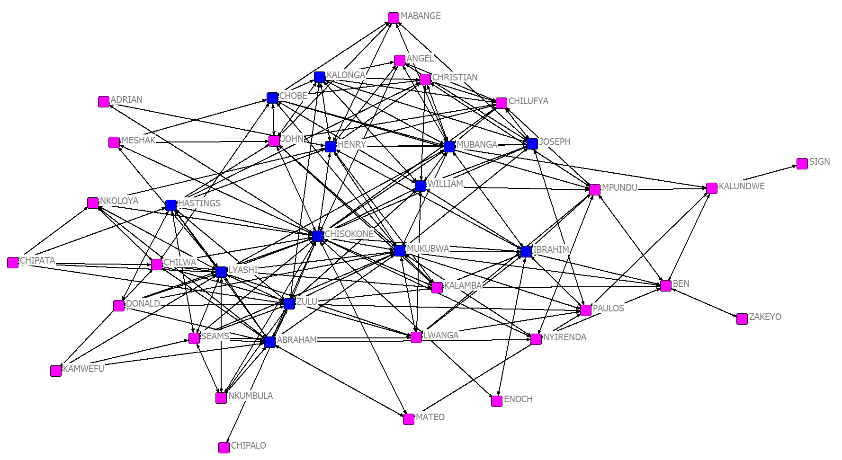
- Transitivity and Simmelian ties with ZACKAR

  - Unpack ZACKAR to get ZACHE and ZACHC (get rid of the prefix if there is one by default, to keep the file names simple).
  - Run Network | Cohesion | Simmelian /Embedded Ties on ZACHE

Output:
Simmelian (Embedded) Ties

1 2 3 4 5 6 7 8 9 10 11 12 13 14 15 16 17 18 19 20 21 22 23 24 25 26 27 28 29 30 31 32 33 34
-- -- -- -- -- -- -- -- -- -- -- -- -- -- -- -- -- -- -- -- -- -- -- -- -- -- -- -- -- -- -- -- -- --
1 0 7 5 5 2 2 2 3 1 0 2 0 1 3 0 0 0 1 0 1 0 1 0 0 0 0 0 0 0 0 0 0 0 0
2 7 0 4 4 0 0 0 3 0 0 0 0 0 3 0 0 0 1 0 1 0 1 0 0 0 0 0 0 0 0 0 0 0 0
3 5 4 0 4 0 0 0 3 2 0 0 0 0 3 0 0 0 0 0 0 0 0 0 0 0 0 0 0 0 0 0 0 1 0
4 5 4 4 0 0 0 0 3 0 0 0 0 1 3 0 0 0 0 0 0 0 0 0 0 0 0 0 0 0 0 0 0 0 0
5 2 0 0 0 0 0 1 0 0 0 1 0 0 0 0 0 0 0 0 0 0 0 0 0 0 0 0 0 0 0 0 0 0 0
6 2 0 0 0 0 0 2 0 0 0 1 0 0 0 0 0 1 0 0 0 0 0 0 0 0 0 0 0 0 0 0 0 0 0
7 2 0 0 0 1 2 0 0 0 0 0 0 0 0 0 0 1 0 0 0 0 0 0 0 0 0 0 0 0 0 0 0 0 0
8 3 3 3 3 0 0 0 0 0 0 0 0 0 0 0 0 0 0 0 0 0 0 0 0 0 0 0 0 0 0 0 0 0 0
9 1 0 2 0 0 0 0 0 0 0 0 0 0 0 0 0 0 0 0 0 0 0 0 0 0 0 0 0 0 0 2 0 3 2
10 0 0 0 0 0 0 0 0 0 0 0 0 0 0 0 0 0 0 0 0 0 0 0 0 0 0 0 0 0 0 0 0 0 0
11 2 0 0 0 1 1 0 0 0 0 0 0 0 0 0 0 0 0 0 0 0 0 0 0 0 0 0 0 0 0 0 0 0 0
12 0 0 0 0 0 0 0 0 0 0 0 0 0 0 0 0 0 0 0 0 0 0 0 0 0 0 0 0 0 0 0 0 0 0
13 1 0 0 1 0 0 0 0 0 0 0 0 0 0 0 0 0 0 0 0 0 0 0 0 0 0 0 0 0 0 0 0 0 0
14 3 3 3 3 0 0 0 0 0 0 0 0 0 0 0 0 0 0 0 0 0 0 0 0 0 0 0 0 0 0 0 0 0 0
15 0 0 0 0 0 0 0 0 0 0 0 0 0 0 0 0 0 0 0 0 0 0 0 0 0 0 0 0 0 0 0 0 1 1
16 0 0 0 0 0 0 0 0 0 0 0 0 0 0 0 0 0 0 0 0 0 0 0 0 0 0 0 0 0 0 0 0 1 1
17 0 0 0 0 0 1 1 0 0 0 0 0 0 0 0 0 0 0 0 0 0 0 0 0 0 0 0 0 0 0 0 0 0 0
18 1 1 0 0 0 0 0 0 0 0 0 0 0 0 0 0 0 0 0 0 0 0 0 0 0 0 0 0 0 0 0 0 0 0
19 0 0 0 0 0 0 0 0 0 0 0 0 0 0 0 0 0 0 0 0 0 0 0 0 0 0 0 0 0 0 0 0 1 1
20 1 1 0 0 0 0 0 0 0 0 0 0 0 0 0 0 0 0 0 0 0 0 0 0 0 0 0 0 0 0 0 0 0 0
21 0 0 0 0 0 0 0 0 0 0 0 0 0 0 0 0 0 0 0 0 0 0 0 0 0 0 0 0 0 0 0 0 1 1
22 1 1 0 0 0 0 0 0 0 0 0 0 0 0 0 0 0 0 0 0 0 0 0 0 0 0 0 0 0 0 0 0 0 0
23 0 0 0 0 0 0 0 0 0 0 0 0 0 0 0 0 0 0 0 0 0 0 0 0 0 0 0 0 0 0 0 0 1 1
24 0 0 0 0 0 0 0 0 0 0 0 0 0 0 0 0 0 0 0 0 0 0 0 0 0 0 0 1 0 2 0 0 2 3
25 0 0 0 0 0 0 0 0 0 0 0 0 0 0 0 0 0 0 0 0 0 0 0 0 0 1 0 0 0 0 0 1 0 0
26 0 0 0 0 0 0 0 0 0 0 0 0 0 0 0 0 0 0 0 0 0 0 0 0 1 0 0 0 0 0 0 1 0 0
27 0 0 0 0 0 0 0 0 0 0 0 0 0 0 0 0 0 0 0 0 0 0 0 0 0 0 0 0 0 1 0 0 0 1
28 0 0 0 0 0 0 0 0 0 0 0 0 0 0 0 0 0 0 0 0 0 0 0 1 0 0 0 0 0 0 0 0 0 1
29 0 0 0 0 0 0 0 0 0 0 0 0 0 0 0 0 0 0 0 0 0 0 0 0 0 0 0 0 0 0 0 1 0 1
30 0 0 0 0 0 0 0 0 0 0 0 0 0 0 0 0 0 0 0 0 0 0 0 2 0 0 1 0 0 0 0 0 2 3
31 0 0 0 0 0 0 0 0 2 0 0 0 0 0 0 0 0 0 0 0 0 0 0 0 0 0 0 0 0 0 0 0 2 2
32 0 0 0 0 0 0 0 0 0 0 0 0 0 0 0 0 0 0 0 0 0 0 0 0 1 1 0 0 1 0 0 0 1 2
33 0 0 1 0 0 0 0 0 3 0 0 0 0 0 1 1 0 0 1 0 1 0 1 2 0 0 0 0 0 2 2 1 0 10
34 0 0 0 0 0 0 0 0 2 0 0 0 0 0 1 1 0 0 1 0 1 0 1 3 0 0 1 1 1 3 2 2 10 0
These data show, for each dyad, HOW MANY simmelean ties they are embedded in. Actors 33 and 34 are in 10 sets of simmelean ties. They are tightly bound to each other through many mutual interactions. It is going to be hard for them to break from each other.
  - Open ZACHE in NETDRAW, then open (AS A NETWORK) ZACHE-Simmel. Because it has the same actors, they should both be present on the relations tab. Switch between them and see the difference.

Zache Network:

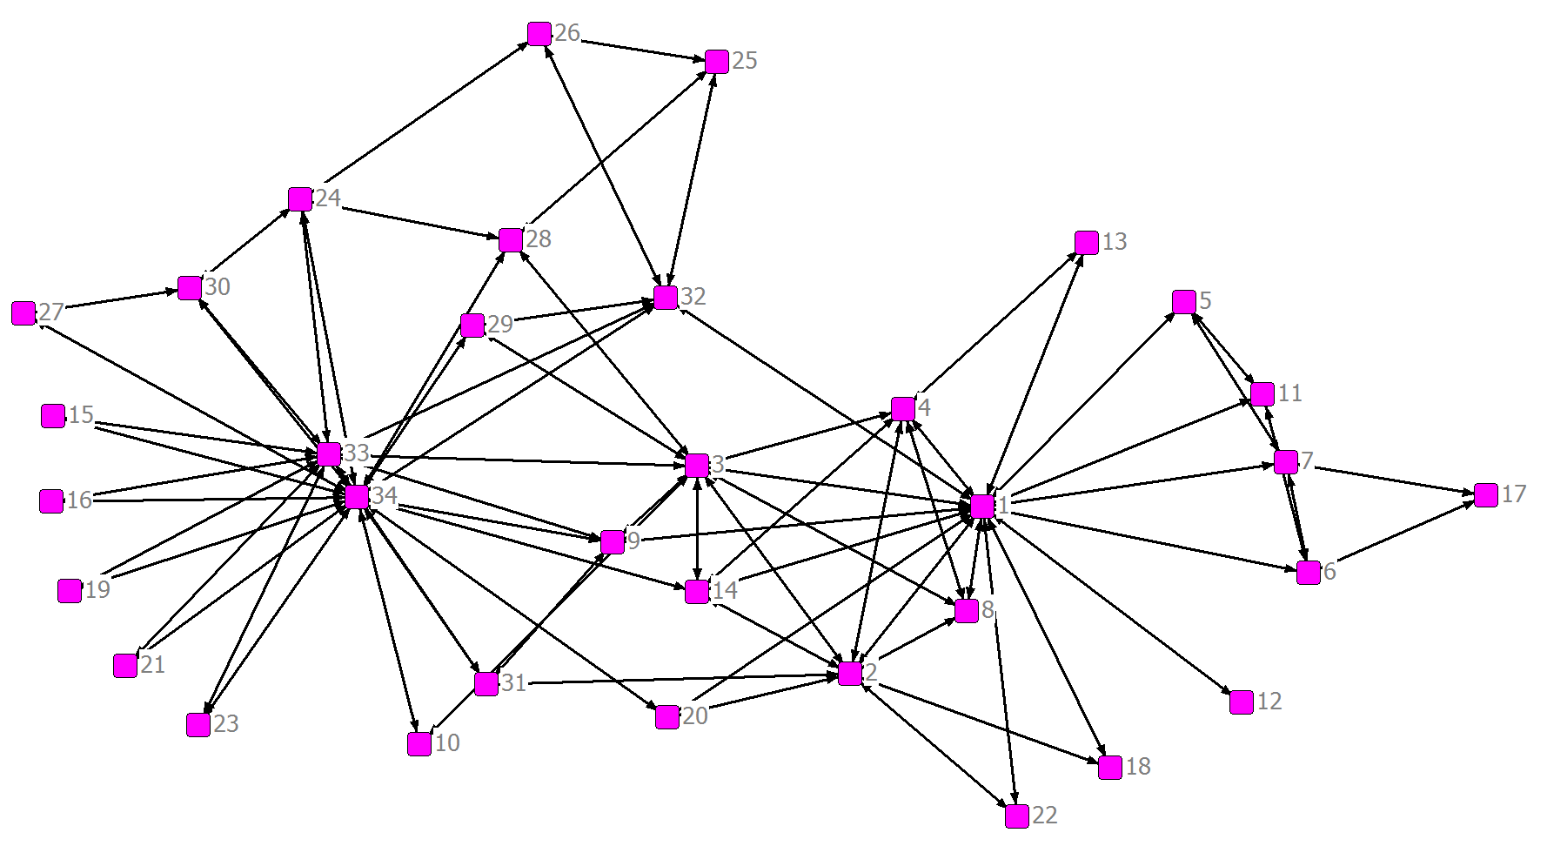
Zache-Simmel Network:

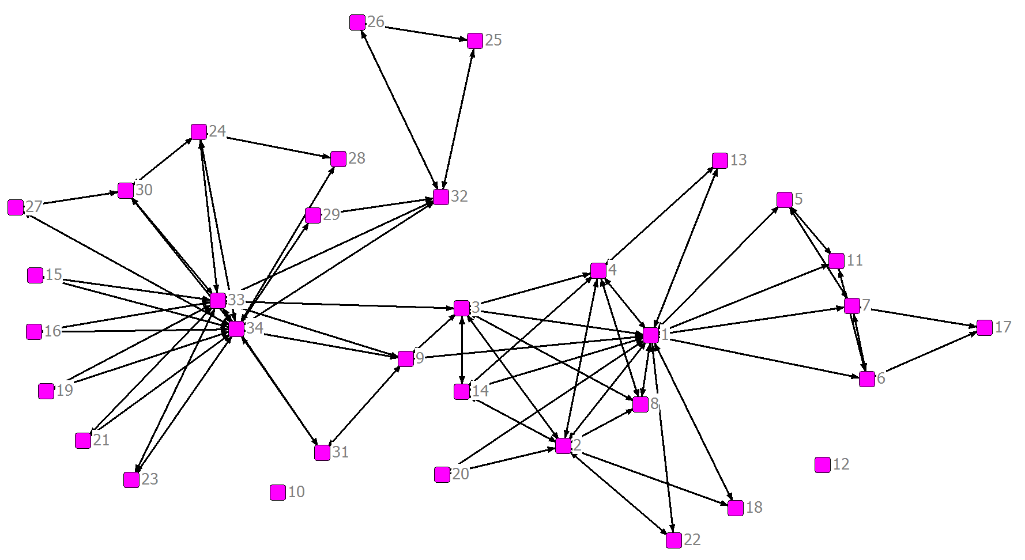
The two networks are quite similar. The Zache network contains 156 ties and the Zache-Simmel contains 134 ties, all of which overlap with the Zache network. Thus, the Zache network contains 22 pairs that do not have Simmelian ties with one another.

  - Select only ZACHE-Simmel relation. The output from the Simmelian tie analysis is a network with the COUNT of how many Simmelian ties each pair of actors share. Turn on the link weights to see those counts. Which actors have the MOST sets of embedded ties?
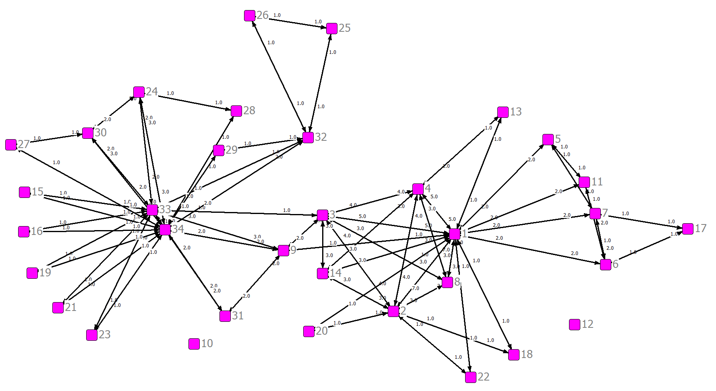
Although it is difficult to see here, the link weight between nodes 1 and 2 is 7. These two nodes are therefore in 7 distinct Simmelian triangles. Note that we can also see this in the matrix above.
  - Turn off the link weights and check both relations. Go to Properties | Lines | Color Relations. Choose a different color for ZACHE, ZACHE-Simmel, and “Multiplex” (which is when a line represents more than on relationship, in this case both ZACHE and ZACHE-Simmel). How much of this network is embedded in Simmelian ties?
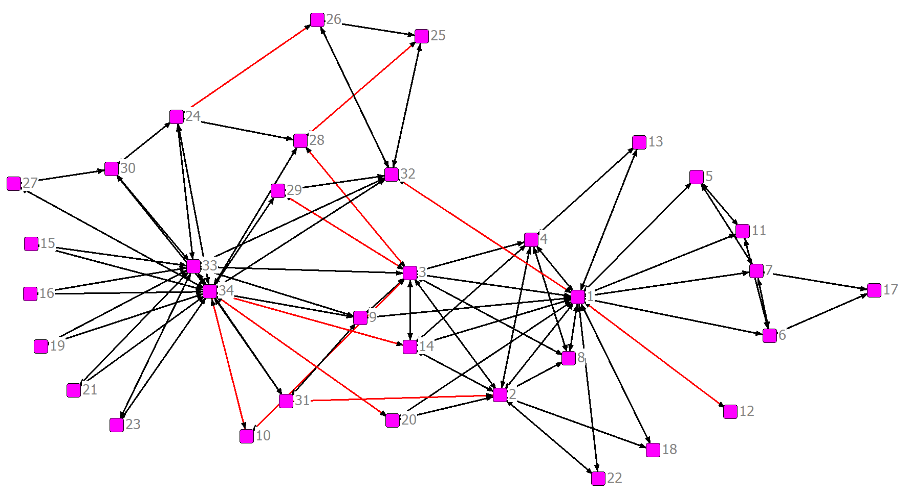
Multiplex ties are black and Zache ties are red (there are no purely Zache-Simmel ties). You should be able to count 11 bi-directional red lines, meaning that there 22 non-Simmelian ties in the network. There are a total of 156 ties and 134 of them are Simmelian, so about 86% of the dyads in this network share Simmelian ties.
  - Back in UCINET, run Network | Cohesion | Transitivity to see the score. Does it surprise you based on the previous analysis in NetDraw?

Below is the output for transitivity on the Zache network using triplets as the method:

TRANSITIVITY
--------------------------------------------------------------------------------

Input Network dataset: zache (C:\Users\Travis\Documents\UCINET data\zache
Output Measures: zache-transit (C:\Users\Travis\Documents\UCINET data\zache-transit
Method: Triplets (C:\Users\Travis\Documents\UCINET data\Triplets

Triplet Transitivity

1
-----
1 0.256

1 rows, 1 columns, 1 levels.

We see that transitivity is .256, or 25.6% of the triples in the network are transitive. This may seem low compared to your intuition based on the visualization. There are, however, many sets of two legs that do not contain a third (i.e., open triads) that do not seem obvious from visual inspection.

